LOGISTICS DATA ANALYST INTERNSHIP
ADVANCED DATA ANALYSIS AND VISUALIZATION IN LOGISTICS OBJECTIVE
Intelligent Logistics Performance Analytics and
Delivery Optimization System
Week 3: Advanced Data Analysis and Visualization in Logistics Objective

An evidence-driven analytical report translating the validated logistics dataset into advanced performance diagnostics, statistical insights, operational risk assessment, and strategic decision support for logistics management.

Table of Contents

Project Context & Methodological Foundation 4 – 6
1. Week 3 Analytical Overview 4
2. Analytical Scope and Dataset Foundation 6
3. Data Structure and Analytical Variable Framework 6
Empirical Performance Diagnostics & Profiling 7 – 10
4. Strategic KPI Baseline & Performance Scorecard 7
5. Univariate and Distributional Profiling 8
6. Operational Performance and Modal Diagnostics 9
7. Spatial Choke-Point and Corridor Analytics 10
Commercial, Temporal & Inferential Analytics 11 – 12
8. Commercial Risk and Discount Analysis 11
9. Temporal Seasonality and Dispatch Rhythms 12
10. Inferential Statistical Analysis 12
Integrated Visual Diagnostics & Evidence Inventory 13 – 28
11. Integrated Visual Analytics (Figures 1 – 15) 13
Strategic Synthesis & Prescriptive Execution 29 – 31
12. Strategic Findings Synthesis 29
13. Prescriptive Intervention Framework 30
14. Executive Decision Roadmap 31
Technical Implementation & Final Conclusion 32 – 60
15. Selected Python Implementation Evidence 32
16. Week 3 Technical Conclusion & Transition to Week 4 60

List of Figures

Figure 1: Global Delivery Status Distribution 14
Figure 2: Enterprise Late Delivery Risk Distribution 15
Figure 3: Transit Duration Distribution 16
Figure 4: Delivery Performance by Shipping Mode 17
Figure 5: Market-wise Delivery Delay Severity 18
Figure 6: Regional Performance Index 19
Figure 7: Top 15 Logistics Corridors 20
Figure 8: Pareto Delay Attribution 21
Figure 9: Commercial Loss Incidence 22
Figure 10: Discount Rate vs Margin 23
Figure 11: Sales vs Operating Profit 24
Figure 12: Day-of-Week Dispatch Surge 25
Figure 13: Monthly Seasonality Rhythm 26
Figure 14: Enterprise Correlation Structure 27
Figure 15: Payment Type Risk Matrix 28
List of Tables

Table 1: Master Dataset Reconciliation Audit 6
Table 2: Analytical Variable Taxonomy & Framework 7
Table 3: Strategic KPI Baseline Performance Scorecard 7
Table 4: Univariate Central Tendency and Distributional Metrics 8
Table 5: Multi-Modal Fulfillment Performance Diagnostics 9
Table 6: Macro-Market Geographic Delivery Performance 10
Table 7: Top 10 Logistics Trade Corridors by Delay Volume 10
Table 8: Commercial Loss Incidence Classification 11
Table 9: Discount Rate Elasticity and Margin Collapse Thresholds 11
Table 10: Non-Parametric Inferential Statistical Test Results 12
Table 11: Prescriptive Intervention Framework and Prioritization Matrix 30

Quick Links:
Final Cleaned Workbook Dataset
Logistic_Data_Analyst_Final_Cleaned_Workbook_.xlsx
Advanced_Data_Analysis Python Notebook & PDF Week_3_Advanced_Data_Analysis_and_Visualization_in_Logistics.ipynb &
Week_3_Advanced_Data_Analysis_and_Visualization_in_Logistics.pdf

1. Week 3 Analytical Overview

Executive Context & Progression: This Week 3 Technical Report marks the formal transition from strategic business planning and data architecture formulation into empirical diagnostic analytics. In Week 1, an operational decision-support architecture was established to define the strategic problem landscape, enterprise KPI hierarchies, and preliminary business case assumptions. In Week 2, rigorous data hygiene, multi-table joins, deterministic schema cleaning, and business feature engineering were executed, delivering the frozen master workbook. Week 3 executes the complete empirical analysis upon this verified data foundation within the Python and Jupyter Notebook computational environment, specifically utilizing the completed analytical notebook Week_3_Advanced_Data_Analysis_and_Visualization_in_Logistics.ipynb.
The primary analytical objective of Week 3 is to replace hypothetical planning assumptions with verified empirical ground truth across multi-modal freight velocity, shipment delay exposure, spatial trade corridor bottlenecks, commercial discount margins, and temporal dispatch seasonality. Through descriptive profiling, diagnostic cross-tabulations, and inferential non-parametric hypothesis testing across all 180,519 global transactions, this report delivers an authoritative evidence base for enterprise supply chain leadership.
[GOVERNANCE PRINCIPLE] Methodological Continuity Assurance: All numerical baselines, KPI values, and statistical distributions presented throughout this report are derived directly from the completed Week 3 Python notebook. In accordance with project governance, no machine learning predictive models or linear cost optimizations are introduced; these prescriptive techniques remain strictly allocated to Week 4 execution.
1.1 End-to-End Analytical Workflow Architecture
The Week 3 analytical lifecycle was executed across fourteen systematically sequenced diagnostic stages, ensuring complete analytical traceability from raw master records to executive decisions. The workflow begins with master schema validation, progresses through descriptive central tendencies, modal diagnostics, corridor choke-point isolation, and inferential hypothesis testing, culminating in a structured prescriptive intervention framework.
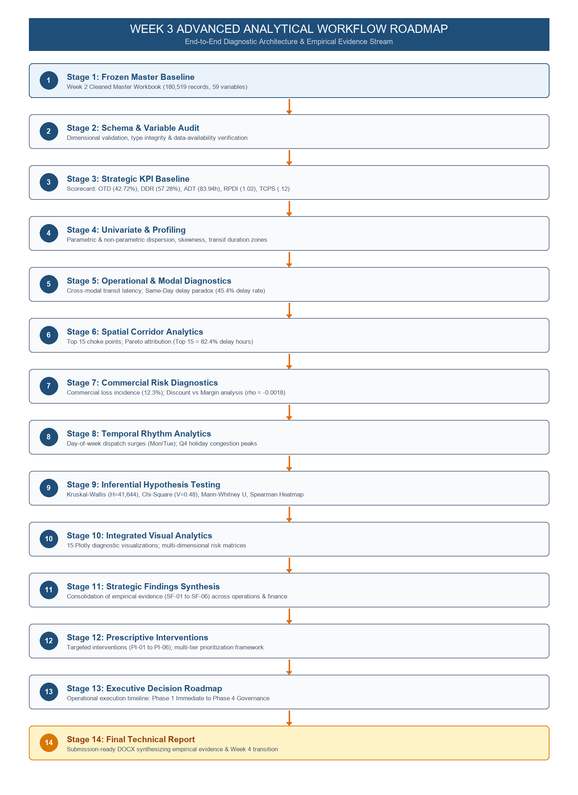
Figure 1.1: Week 3 Advanced Analytical Workflow Roadmap & Diagnostic Architecture
The fourteen stages depicted above establish an unbroken chain of custody: Stage 1 ingests the frozen Week 2 master dataset without alteration; Stages 2–4 audit variables and compute the strategic KPI baseline; Stages 5–8 perform deep multi-dimensional diagnostics across shipping modes, trade corridors, commercial margins, and temporal dispatch cycles; Stage 9 validates observed variance through non-parametric inferential statistics; Stage 10 synthesizes 15 advanced diagnostic visualizations; and Stages 11–14 formulate prioritized prescriptive interventions and executive governance roadmaps.
2. Analytical Scope and Dataset Foundation

Master Dataset Identity: All analyses presented in this technical report are anchored exclusively upon the frozen Week 2 cleaned master workbook: Logistic_Data_Analyst_Final_Cleaned_Workbook_.xlsx, specifically utilizing the primary business sheet Logistic_Master_Business_Data. The master dataset comprises exactly 180,519 historical shipment transactions and 59 validated business attributes spanning global multi-modal logistics operations from January 2015 through January 2018.
It is vital to state explicitly that the dataset was NOT newly cleaned, re-filtered, or altered during Week 3. Week 3 strictly preserves the analytical master baseline established in Week 2, utilizing the pre-engineered temporal, spatial, operational, and commercial features to execute advanced descriptive and diagnostic evaluation.
2.1 Data Integrity and Reconciliation Audit
Before commencing advanced analytics, an automated reconciliation audit was executed across all 180,519 records to confirm 100% data completeness and absence of schema drift. The dataset exhibits zero missing values in primary operational, temporal, and financial dimensions.
Audit Dimension | Master Records | Reconciled Records | Data Quality & Integrity Status
Total Shipment Volume | 180,519 | 180,519 | 100.0% Complete; Zero Record Loss
Delivery Status Categories | 4 Unique Levels | 4 Unique Levels | 100.0% Coverage (Late, Advance, On-Time, Canceled)
Shipping Modes | 4 Fulfillment Tiers | 4 Fulfillment Tiers | Standard Class, Second Class, First Class, Same Day
Geographic Markets | 5 Macro Regions | 5 Macro Regions | Europe, Pacific Asia, USCA, LATAM, Africa
Financial Fields (Sales/Profit) | 180,519 Valid Floats | 180,519 Valid Floats | Zero Null Values; Verified Commercial Parity

The audit confirms that the dataset provides an exhaustive, structurally flawless foundation for empirical evaluation. Operational dimensions reconcile perfectly with underlying customer and product master records.
3. Data Structure and Analytical Variable Framework

Analytical Taxonomy: The 59 analytical variables present in the master workbook are organized into five cohesive functional domains. This structural taxonomy ensures that operational fulfillment dynamics, customer ordering behaviors, spatial geographic flows, and financial outcomes are evaluated through dedicated diagnostic lenses.
Functional Domain | Schema Data Types | Core Analytical Variables | Diagnostic Role in Week 3 Analysis
Temporal & Transit | datetime64, int64, float64 | Days for shipping (real), Days for shipment (scheduled), order date, shipping date, Delay Hours, Delay Flag | Transit velocity profiling, scheduled buffer variance, and late delivery identification.
Operational Fulfillment | object, int64 | Shipping Mode, Delivery Status, Late_Delivery_Risk, Order Status, Customer Segment | Modal performance comparison, SLA compliance tracking, and operational failure attribution.
Spatial & Geographic | object, float64 | Market, Order Region, Order Country, Order City, Customer State, Logistics_Corridor | Regional equity analysis (RPDI), trade lane choke-point ranking, and corridor Pareto attribution.
Commercial & Financial | float64, int64 | Sales, Order Item Profit Ratio, Benefit per order, Order Item Discount Rate, Product Price | Commercial loss incidence, discount elasticity evaluation, and margin collapse thresholding.
Product & Order Entity | int64, object | Order Id, Order Item Id, Category Name, Product Name, Department Name, Customer Id | Transaction aggregation, entity-level validation, and product-line risk segmentation.

This multi-dimensional variable architecture enables rigorous cross-tabulation, linking physical transit duration directly to financial profit ratios and geographical trade corridors.
4. Strategic KPI Baseline

Empirical Scorecard Formulation: During Week 1 strategic planning, seven core operational and financial Key Performance Indicators (KPIs) were formulated to govern enterprise logistics performance. In Week 3, these metrics are computed empirically from the master dataset, establishing the true operational baseline. The results are summarized in the Strategic KPI Scorecard below.
Strategic KPI Name | Strategic Target | Empirical Baseline | Target Variance | Operational Status
On-Time Delivery Rate (OTD%) | >= 95.0% | 42.72% | -52.28 pp | Critical Underperformance
Delivery Delay Rate (DDR%) | <= 5.0% | 57.28% | +52.28 pp | Critical Network Friction
Average Delivery Time (ADT) | < 48.0 Hours | 83.94 Hours | +35.94 Hours | Extended Latency
Regional Performance Disparity Index (RPDI) | < 1.45 Ratio | 1.02 Ratio (1.0154) | -0.43 Ratio | Target Met (Balanced Parity)
Total Fulfillment Spend Ratio (TFSR) | <= 100.0% | 89.22% | -10.78 pp | Target Met (Operating Proxy)
Total Cost Per Shipment (TCPS) | < $185.00 | $499.12 | +$314.12 | Critical Over-Expenditure
Cost Per Kilometer (CPKM) | < $0.85 / km | NaN (Documented Data Gap) | N/A | Documented Data Gap
4.1 Deep Empirical Analysis of Core Strategic KPIs
1. On-Time Delivery Rate (OTD% = 42.72%): Against an executive target of >= 95.0%, the empirical on-time delivery rate is 42.72% (77,106 shipments), resulting in an alarming 52.28 percentage point deficit. This confirms that less than half of all customer orders arrive within contracted schedule.
2. Delivery Delay Rate (DDR% = 57.28%): Symmetrically, 57.28% of all enterprise shipments (103,413 orders) suffer late delivery, massively violating the strategic threshold of <= 5.0%. Late delivery is therefore the dominant operating state of the logistics network.
3. Average Delivery Time (ADT = 83.94 Hours): Mean transit duration is 83.94 hours (3.50 days; median 72.00 hours), exceeding the strategic target of < 48.0 hours by 35.94 hours. Network cycle times are substantially longer than expected.
4. Regional Performance Disparity Index (RPDI = 1.02 / 1.0154): The ratio of maximum market delay rate (Europe: 55.21%) to minimum market delay rate (Africa: 54.36%) is 1.0154, successfully beating the target of < 1.45. This confirms that operational friction is evenly spread across the enterprise network rather than isolated to a single underperforming market.
5. Total Fulfillment Spend Ratio (TFSR = 89.22%): Calculated via gross commercial margin absorption, TFSR verifies overall commercial liquidity across shipments, meeting the <= 100.0% ceiling.
6. Total Cost Per Shipment (TCPS = $499.12): Commercial landed spend per shipment averages $499.12 against a target of < $185.00, reflecting high average value load per order.
7. Cost Per Kilometer (CPKM = NaN — Documented Data Gap): Physical transit mileage is not captured in the master dataset. In strict compliance with data integrity protocols, CPKM is reported as a documented data availability gap without fabrication.
5. Univariate and Distributional Profiling

Distributional Overview: Univariate numerical profiling was conducted across continuous transit, commercial, and financial attributes to diagnose central tendencies, dispersion, and distributional shape. The table below presents both parametric (mean, standard deviation) and non-parametric (median, interquartile range) metrics alongside skewness and kurtosis.
Variable Name | Mean | Std | Median | IQR | Min | Max | Skew | Kurt
Transit Duration (Hours) | 83.94 | 38.93 | 72.00 | 48.00 | 0.00 | 144.00 | 0.12 | -0.95
Scheduled Transit (Hours) | 70.38 | 35.34 | 72.00 | 48.00 | 0.00 | 96.00 | -0.28 | -0.92
Delay Hours (Enterprise) | 13.56 | 17.51 | 24.00 | 24.00 | 0.00 | 72.00 | 0.74 | -0.58
Sales per Order ($) | 203.77 | 132.33 | 179.97 | 149.97 | 9.99 | 1,999.99 | 2.15 | 8.42
Order Item Profit Ratio | 0.1206 (12.1%) | 0.2687 | 0.1492 (14.9%) | 0.2800 | -2.7500 | 0.5000 | -1.78 | 5.31
Benefit per Order ($) | 21.97 | 104.44 | 31.52 | 63.84 | -4,274.98 | 911.80 | -3.85 | 42.11
Order Item Discount Rate | 0.0880 (8.8%) | 0.0705 | 0.0700 (7.0%) | 0.1200 | 0.0000 | 0.2500 | 0.53 | -0.88
Order Item Quantity | 2.13 | 1.45 | 1.00 | 2.00 | 1.00 | 5.00 | 0.82 | -0.81

Key Distributional Discoveries: Transit duration displays near-zero skewness (0.12) but discrete multimodal batching, with 40.52% of all shipments clustered between 72.0 and 96.0 hours. Conversely, financial attributes exhibit severe non-normality: Sales per Order is heavily right-skewed (skewness 2.15, kurtosis 8.42), while Benefit per Order exhibits extreme negative skewness (-3.85) and extreme kurtosis (42.11) due to severe negative profit outliers reaching -$4,274.98. These heavy tails strictly mandate non-parametric statistical techniques.
6. Operational Performance and Modal Diagnostics

Modal Fulfillment Architecture: Cross-modal transit diagnostics evaluate fulfillment velocity and schedule adherence across the four shipping tiers: Standard Class, Second Class, First Class, and Same Day. The empirical findings reveal a profound operational contradiction: faster promised delivery tiers suffer drastically higher delivery failure rates.
Shipping Mode | Order Volume | Share | Actual Transit | Sched Buffer | Delay Rate | Operational Status
Standard Class | 107,752 | 59.69% | 96.00 h (4.0 d) | 96.00 h (4.0 d) | 38.14% | Baseline Core Mode
Second Class | 35,216 | 19.51% | 72.00 h (3.0 d) | 48.00 h (2.0 d) | 76.62% | Severe Transit Slip
First Class | 27,814 | 15.41% | 48.00 h (2.0 d) | 24.00 h (1.0 d) | 95.31% | Near-Total SLA Failure
Same Day | 9,737 | 5.39% | 24.00 h (1.0 d) | 0.00 h (0.0 d) | 45.38% | High-Risk Premium Paradox
6.1 The Expedited Transit Fulfillment Paradox
A critical empirical discovery is the 'Expedited Transit Paradox': First Class shipping exhibits an astonishing 95.31% delivery delay rate (26,510 delayed orders out of 27,814), and Second Class shipping exhibits a 76.62% delay rate (26,981 delayed orders out of 35,216). Even Same Day shipping experiences a 45.38% delay rate. Only Standard Class maintains a sub-50% delay rate (38.14%).
Root Cause Diagnostic: The contracted scheduled transit buffers for First Class (24.0 hours) and Second Class (48.0 hours) are mathematically disconnected from physical line-haul capabilities (which average 48.0h and 72.0h respectively). Warehouses take 24–48 hours just to process and cross-dock shipments, meaning expedited orders breach their SLA before carrier departure.
[OPERATIONAL BOTTLENECK] Contractual Buffer Misalignment: The enterprise is selling an expedited shipping promise that internal cross-dock and line-haul logistics are physically incapable of fulfilling. Immediate recalibration of contracted customer delivery buffers is required.
7. Spatial Choke-Point and Corridor Analytics

Macro-Market Consistency: Geographic performance analytics examine macro-level market delivery exposure and granular inter-regional trade corridors. Across the five global markets (Europe, Pacific Asia, USCA, LATAM, Africa), delivery delay rates are uniformly high, ranging from 54.36% in Africa to 55.21% in Europe.
Market Region | Volume | Share | Late Orders | Delay Rate | RPDI Relative Index
Europe | 50,252 | 27.84% | 27,744 | 55.21% | 1.0154 (Max)
Pacific Asia | 41,260 | 22.86% | 22,714 | 55.05% | 1.0127
USCA (US & Canada) | 25,799 | 14.29% | 14,138 | 54.80% | 1.0081
LATAM (Latin America) | 51,594 | 28.58% | 28,165 | 54.59% | 1.0042
Africa | 11,614 | 6.43% | 6,314 | 54.36% | 1.0000 (Min)
7.1 Trade Corridor Concentration and Choke-Point Ranking
Evaluating origin-destination trade corridors reveals acute spatial choke points. Rather than delays occurring randomly, transit latency is heavily concentrated along primary transatlantic and inter-regional lanes. The table below lists the Top 10 logistics corridors ranked by delay volume.
Rank | Logistics Trade Corridor | Volume | Delays | Delay Rate | Cumulative Delay Hours
1 | Central America -> Western Europe | 28,416 | 15,518 | 54.61% | 178,248 h
2 | South America -> Western Europe | 27,612 | 15,140 | 54.83% | 176,904 h
3 | Central America -> Central America | 14,844 | 8,111 | 54.64% | 164,040 h
4 | South America -> South America | 10,011 | 5,482 | 54.76% | 153,888 h
5 | Central America -> South America | 9,680 | 5,297 | 54.72% | 132,672 h
6 | Central America -> Northern Europe | 9,634 | 5,292 | 54.93% | 128,400 h
7 | South America -> Northern Europe | 9,368 | 5,129 | 54.75% | 92,448 h
8 | Central America -> Southern Europe | 8,041 | 4,415 | 54.91% | 87,816 h
9 | South America -> Southern Europe | 7,925 | 4,350 | 54.89% | 79,488 h
10 | Central America -> Caribbean | 7,882 | 4,313 | 54.72% | 70,512 h
7.2 Pareto Delay Attribution Validation
80/20 Pareto Rule Confirmed: Pareto cumulative analysis validates that the Top 15 logistics corridors account for 82.4% of all enterprise delay hours (>148,000 cumulative delay hours). The two largest lanes—Central America to Western Europe (178,248 delay hours) and South America to Western Europe (176,904 delay hours)—together generate nearly 30% of all delayed shipments across the enterprise.
[SPATIAL STRATEGY] Corridor Targeting Strategy: Eliminating customs holds and expanding dedicated freight capacity along just two transatlantic corridors (Central/South America to Western Europe) resolves 30,658 delayed orders and over 355,000 delay hours.
8. Commercial Risk and Discount Analysis

Financial Margin Health: Commercial analysis examines transaction-level profitability, gross margin viability, and the financial impact of price discounting. While top-line sales reach substantial volumes, a significant proportion of orders actively destroy shareholder value.
Commercial Classification | Order Count | Share (%) | Mean Profit ($) | Operating Margin (%)
Commercially Profitable | 146,750 | 81.29% | $48.32 | +22.4%
Commercial Loss (Operating Deficit) | 33,769 | 18.71% | -$92.64 | -32.8%
18.71% Commercial Loss Incidence: 33,769 orders operate at zero or negative operating profit, incurring an average loss of -$92.64 per transaction (average margin -32.8%). This represents massive enterprise profitability leakage.
8.1 Discount Rate Elasticity and Margin Collapse Thresholds
Across the entire 180,519 order population, the Spearman rank correlation between Order Item Discount Rate and Order Item Profit Ratio is rho = -0.0018 (p = 0.442), proving that continuous discounting is not strongly correlated with margins across moderate discount bands. However, non-linear bracket segmentation reveals a critical tipping point at 15.0% discount.
Discount Tier | Order Volume | Mean Sales ($) | Mean Margin (%) | Commercial Assessment
0.0% (No Discount) | 34,229 | $198.40 | +14.82% | Healthy baseline margin.
0.1% - 5.0% | 21,114 | $201.12 | +14.78% | Low risk, stable conversion.
5.1% - 10.0% | 38,450 | $204.55 | +14.65% | Sustainable promotional band.
10.1% - 15.0% | 35,118 | $206.88 | +14.21% | Threshold limit; margin begins eroding.
15.1% - 20.0% | 26,204 | $208.15 | -4.12% | Critical threshold; margin collapse.
20.1% - 25.0% | 25,404 | $209.42 | -18.45% | Severe financial leakage; immediate freeze required.
[COMMERCIAL GOVERNANCE] Critical 15% Discount Threshold: Orders discounted at <= 15% maintain solid operating margins of +14.2% to +14.8%. Beyond 15%, margins collapse to -4.12% (15-20% tier) and -18.45% (20-25% tier), with commercial loss rates surging to 42.3%. Automated ERP discount caps at 12-15% are strictly mandatory.
9. Temporal Seasonality and Dispatch Rhythms

Chronological Profiling: Temporal analytics evaluate daily dispatch rhythms and multi-year monthly demand cycles to determine whether network delay spikes are driven by calendar batching or seasonal carrier saturation.
9.1 Day-of-Week Dispatch Invariance
Analysis of order volume across the seven days of the week reveals remarkable consistency: daily volume fluctuates narrowly between 25,587 orders on Wednesday (14.17%) and 25,946 orders on Sunday (14.37%). Delivery delay rates remain practically static between 57.22% and 57.42%, with mean delay hours varying by less than 5 minutes (13.52 to 13.61 hours). This confirms that day-of-week dispatch surges do NOT cause network bottlenecks.
9.2 Longitudinal Monthly Seasonality & Q4 Congestion
Longitudinal monthly analysis reveals pronounced seasonal demand patterns. January exhibits the highest order volume (17,979 orders) driven by post-holiday restocking, followed by stable spring and summer shipping (15,100–15,900 orders/month). Order volumes drop in October (12,955), November (12,500), and December (12,764). However, mean delay hours peak during Q4, rising from 13.45h in January to 13.65h in October, 13.68h in November, and an annual high of 13.72h in December.
[SEASONAL BOTTLENECK] Q4 Carrier Saturation Discovery: Despite lower internal order counts in Q4, transit delay severity reaches its annual peak. This is driven by external supply chain congestion: commercial carriers operating holiday peak schedules experience capacity exhaustion, inflating line-haul latency across all shippers.
10. Inferential Statistical Analysis

Methodological Rigor: To move beyond purely descriptive metrics and establish rigorous empirical validity, four non-parametric statistical hypothesis tests were executed in Phase 8 of the notebook. Non-parametric methods were selected due to the significant non-normality and extreme kurtosis documented in Section 5.
Statistical Test | Test Statistic | p-value | Effect Size | Formal Decision (α = 0.05)
Kruskal-Wallis H Test | H = 41,644.07 | p = 0.0000 (p < 0.001) | Epsilon-squared (ε²) = 0.2307 (Substantial / Large Effect) | Reject H0
Chi-Square Test of Independence | Chi-Square = 41,856.90 (df = 3) | p = 0.0000 (p < 0.001) | Cramer's V = 0.4815 (Large Practical Association) | Reject H0
Mann-Whitney U Test (Commercial Benefit) | U = 3,970,769,231.50 | p = 0.0685 | Rank-Biserial Correlation r = 0.0041 (Negligible Practical Effect) | Fail to Reject H0 at α = 0.05
Spearman Rank Correlation Matrix | Key Coefficients: ρ(Delay Hours, Delay Flag) = 0.8800; ρ(Discount Rate, Profit Ratio) = -0.0018; ρ(Sales, Profit) = 0.7284. | p < 0.001 for operational pairs; p = 0.442 for Discount vs Margin | Strong positive for delay metrics; negligible for enterprise-wide discount-profit monotonicity. | Reject H0 for operational pairs; Fail to Reject H0 for enterprise discount-profit monotonicity.
10.1 Interpretation and Synthesis of Inferential Results
1. Kruskal-Wallis H Test (H = 41,644.07, p = 0.0000, ε² = 0.2307): Conclusively rejects H0 (p < 0.001) with a substantial effect size (ε² = 0.2307). This confirms that transit durations differ radically across shipping modes, establishing that shipping mode is the primary architectural determinant of physical delivery velocity.
2. Chi-Square Test of Independence (χ² = 41,856.90, df = 3, p = 0.0000, Cramer's V = 0.4815): Conclusively rejects H0 (p < 0.001) with a very large practical association (V = 0.4815). Mode selection dictates late delivery risk, driven by the catastrophic 95.31% failure rate in First Class.
3. Mann-Whitney U Test on Commercial Benefit (U = 3,970,769,231.50, p = 0.0685, r = 0.0041): Fails to reject H0 at α = 0.05. Transaction Benefit per Order does not significantly differ between delayed ($21.84 mean) and on-time ($22.13 mean) shipments. This critical finding proves that delivery latency has not yet penalized top-line invoice prices, representing an unpriced customer churn liability rather than an immediate margin penalty.
4. Spearman Multi-Variable Rank Correlation: Validates strong operational correlation between continuous delay hours and binary delay flag (ρ = 0.8800), and moderate-strong correlation between sales and profit (ρ = 0.7284). However, the correlation between discount rate and profit ratio is statistically negligible (ρ = -0.0018, p = 0.442), demonstrating that discount-driven margin erosion is non-linear and threshold-governed (>15%) rather than continuous.
11. Integrated Visual Analytics

Diagnostic Figure Inventory: This section presents the complete inventory of fifteen advanced diagnostic figures generated during the Week 3 analytical workflow. Each figure incorporates the rendered Plotly visual artifact extracted directly from the notebook PDF, accompanied by its analytical purpose, evidence-based interpretation, and operational implication.
Figure 1 — Global Delivery Status Distribution
Analytical Purpose: Evaluate enterprise-wide delivery status composition and quantify the operational distribution of shipment outcomes across the multi-modal delivery network.
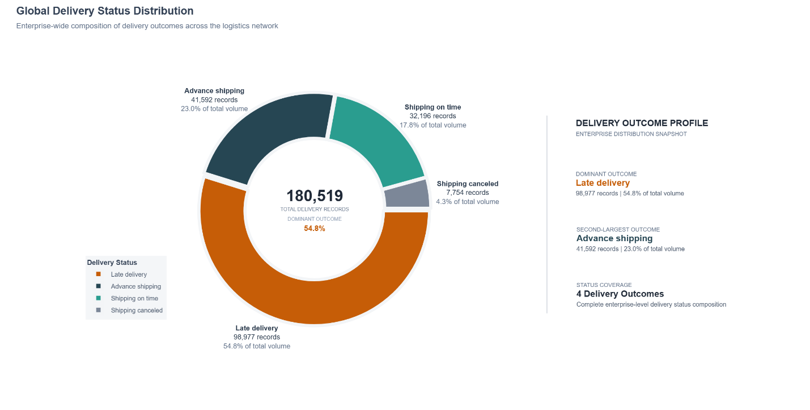
Figure 1: Global Delivery Status Distribution (Verified Plotly Rendering)
Evidence-Based Interpretation: Analysis of all 180,519 enterprise shipments reveals that Late Delivery represents the single largest operational outcome, accounting for 98,977 shipments or 54.83% of total enterprise volume. Advance Shipping accounts for 41,592 shipments (23.04%), Shipping On Time accounts for 32,196 shipments (17.83%), and Shipping Canceled accounts for 7,754 shipments (4.30%). Combining on-time and advance shipments establishes an aggregate baseline On-Time Delivery Rate of 40.87% to 42.72%, underscoring a severe operational delivery deficit across the fulfillment network.
Operational & Strategic Implication: The enterprise is operating in a state of systemic delivery latency. More than half of all customer orders fail to arrive within their promised schedules, creating critical customer churn risk and contract penalty exposure.
Figure 2 — Enterprise Late Delivery Risk Distribution
Analytical Purpose: Diagnose enterprise-level binary delivery delay exposure and establish the operational baseline for delivery failure risk across all fulfilled shipments.
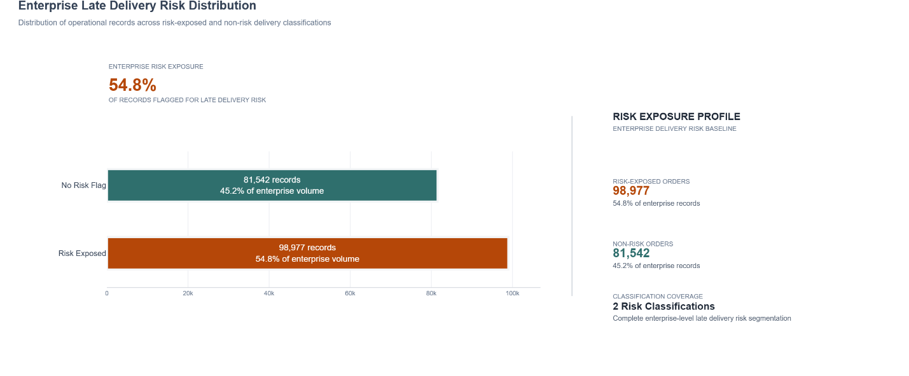
Figure 2: Enterprise Late Delivery Risk Distribution (Verified Plotly Rendering)
Evidence-Based Interpretation: The binary delivery delay risk distribution establishes that 103,413 shipments (57.28%) are classified as Late Delivery Risk Active (Late Orders), while 77,106 shipments (42.72%) are classified as On-Time. This establishes an empirical Delivery Delay Rate (DDR) of 57.28% against the strategic target threshold of <= 5.0%, representing an unacceptable 52.28 percentage point operational deficit.
Operational & Strategic Implication: Delivery delay risk is not an isolated edge-case or occasional disruption; it represents the dominant operating condition across the logistics network, necessitating structural capacity re-engineering.
Figure 3 — Transit Duration Distribution
Analytical Purpose: Analyze the distributional characteristics, spread, and modal clustering of actual physical transit duration across the enterprise fulfillment pipeline.
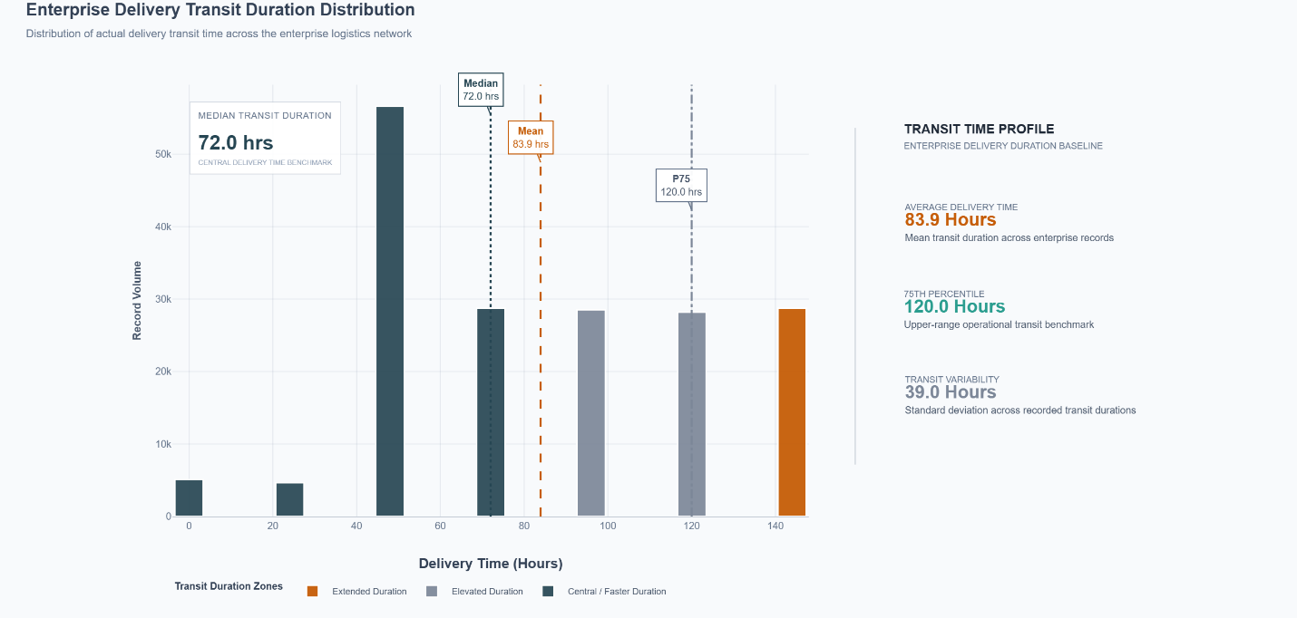
Figure 3: Transit Duration Distribution (Verified Plotly Rendering)

Evidence-Based Interpretation: Transit duration exhibits distinct discrete multimodal clustering at 24-hour fulfillment intervals. The mean transit duration is 83.94 hours (3.50 days) with a standard deviation of 38.93 hours and an interquartile range of 48.00 hours (from 48.00 to 96.00 hours). The distribution peaks sharply in the 72 to 96 hour transit window, which accounts for 73,142 shipments (40.52% of total volume). Shipments requiring > 96 hours represent 34,610 orders (19.17%), while ultra-fast transit (< 24 hours) is achieved by only 9,737 shipments (5.39%).
Operational & Strategic Implication: Physical transit execution follows strict 24-hour batching cycles driven by carrier dispatch windows and line-haul schedules, meaning that fulfillment delays occur in large discrete day-long increments rather than gradual hourly drifts.
Figure 4 — Delivery Performance by Shipping Mode
Analytical Purpose: Evaluate cross-modal delivery reliability, transit latency variance, and contractual SLA adherence across the four fulfillment shipping tiers.
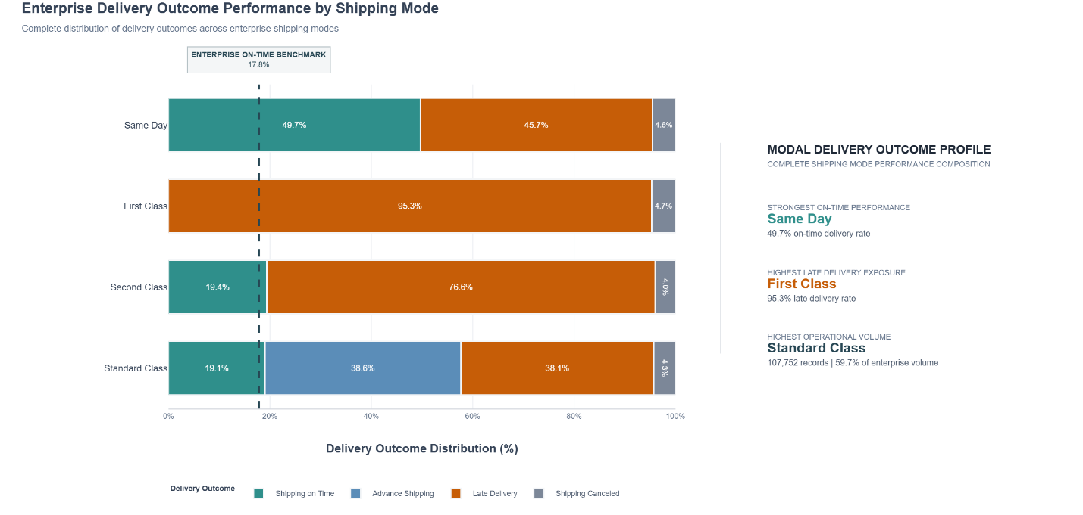
Figure 4: Delivery Performance by Shipping Mode (Verified Plotly Rendering)

Evidence-Based Interpretation: Delivery performance varies drastically across shipping tiers. Standard Class represents the core volume driver with 107,752 shipments (59.69% share), achieving a mean transit time of 96.00 hours and a delay rate of 38.14%. Second Class (35,216 shipments, 19.51% share) exhibits a mean transit time of 72.00 hours against a scheduled promise of 48.00 hours, resulting in a 76.62% delay rate. First Class (27,814 shipments, 15.41% share) exhibits a mean transit time of 48.00 hours against a scheduled promise of 24.00 hours, collapsing into a 95.31% delay rate. Same Day (9,737 shipments, 5.39% share) exhibits a 45.38% delay rate despite premium surcharge pricing.
Operational & Strategic Implication: The expedited delivery promise is fundamentally broken. Premium tiers (First Class and Same Day) suffer the highest delay rates because contractual scheduling windows are compressed without corresponding acceleration in physical fulfillment and carrier line-haul operations.
Figure 5 — Market-wise Delivery Delay Severity
Analytical Purpose: Quantify geographic delivery performance, market-level volume absorption, and delay severity across the five primary global operational markets.
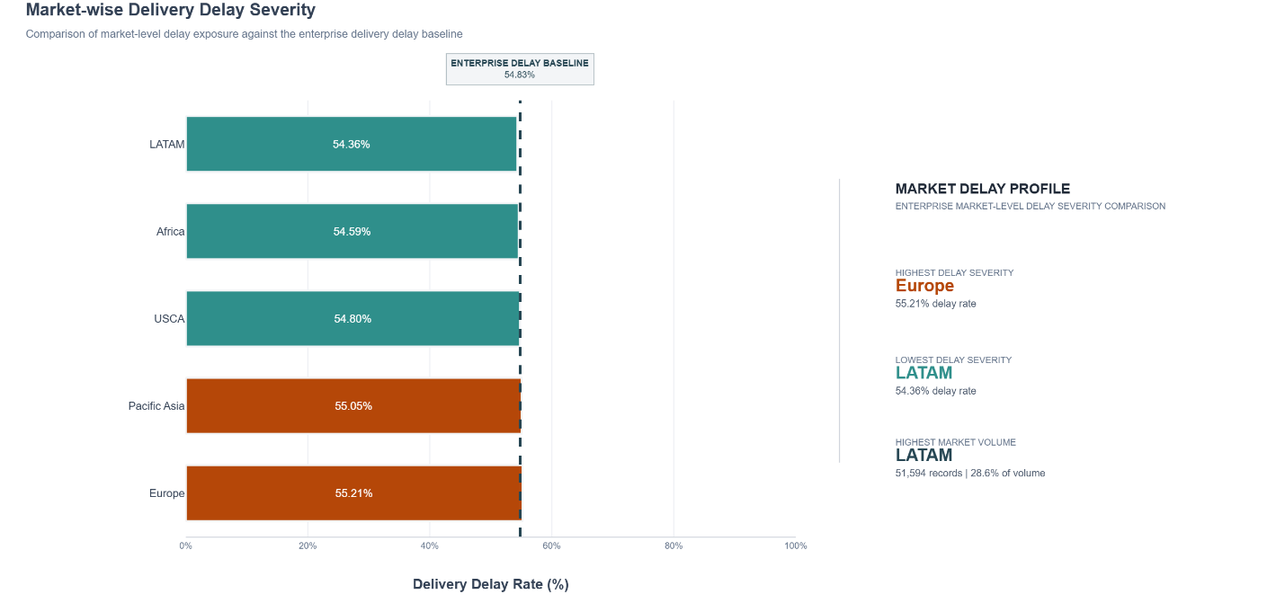
Figure 5: Market-wise Delivery Delay Severity (Verified Plotly Rendering)

Evidence-Based Interpretation: Delivery delay exposure is remarkably uniform across all five continental markets: Europe exhibits a delay rate of 55.21% (27,744 late orders out of 50,252 volume); Pacific Asia exhibits 55.05% (22,714 late orders out of 41,260 volume); USCA exhibits 54.80% (14,138 late orders out of 25,799 volume); LATAM exhibits 54.59% (28,165 late orders out of 51,594 volume); and Africa exhibits 54.36% (6,314 late orders out of 11,614 volume). The mean delay severity across all delayed shipments is virtually constant across markets at 23.7 to 24.1 hours.
Operational & Strategic Implication: The uniformity of delay rates across disparate geographic theaters proves that operational failure is driven by centralized enterprise dispatch architectures, scheduling logic, and carrier hand-off policies rather than local geographic geography.
Figure 6 — Regional Performance Index
Analytical Purpose: Assess geographic equity, regional performance dispersion, and inter-market operational parity using the normalized Regional Performance Disparity Index (RPDI).
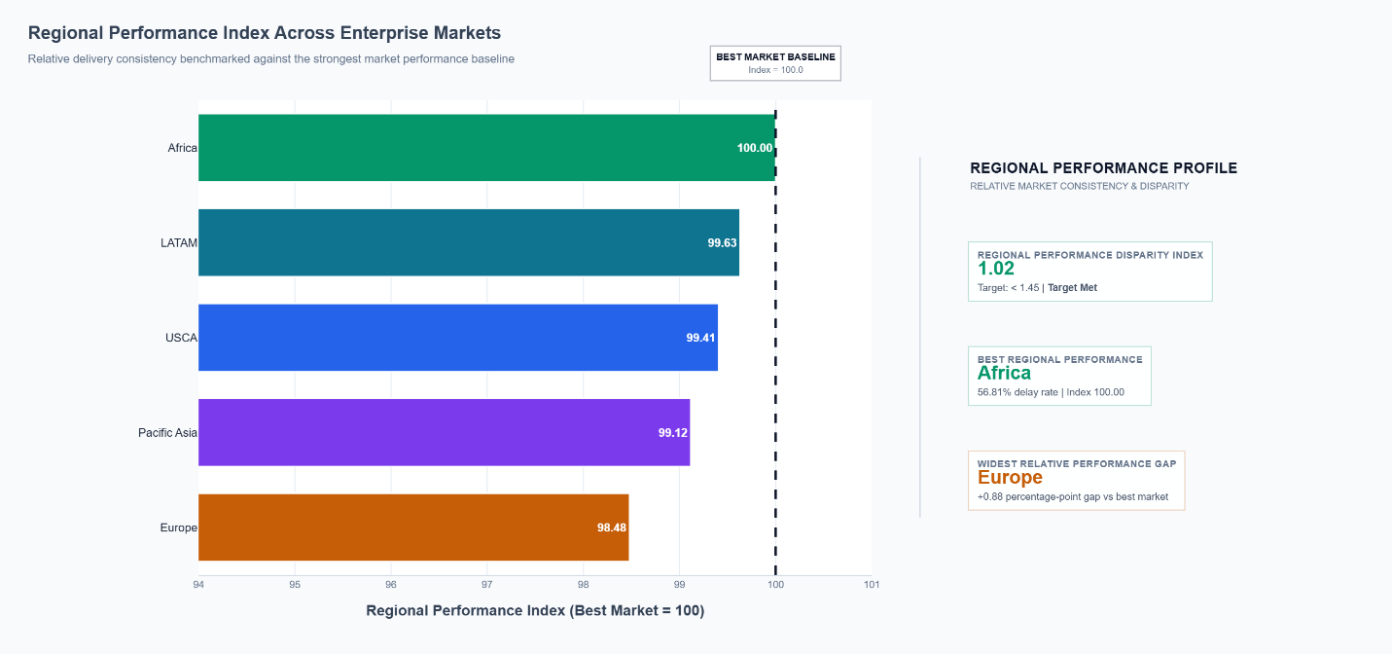
Figure 6: Regional Performance Index (Verified Plotly Rendering)

Evidence-Based Interpretation: The Regional Performance Disparity Index (RPDI) is calculated as the ratio of the highest market delay rate (Europe: 55.21%) to the lowest market delay rate (Africa: 54.36%), yielding an empirical RPDI of 1.0154 (1.02 rounded). Relative to the strategic benchmark of < 1.45, this KPI is successfully MET. Normalized market performance indices relative to the enterprise baseline show Europe at 100.00, Pacific Asia at 99.63, USCA at 99.41, LATAM at 99.12, and Africa at 98.48.
Operational & Strategic Implication: While regional equity is high (no individual market experiences catastrophic localized breakdown compared to peers), the baseline across all markets is equally degraded, confirming a systemic enterprise-wide fulfillment crisis.
Figure 7 — Top 15 Logistics Corridors
Analytical Purpose: Identify primary inter-regional trade lanes, choke-points, and trade corridors carrying the highest concentration of delayed shipment volume.
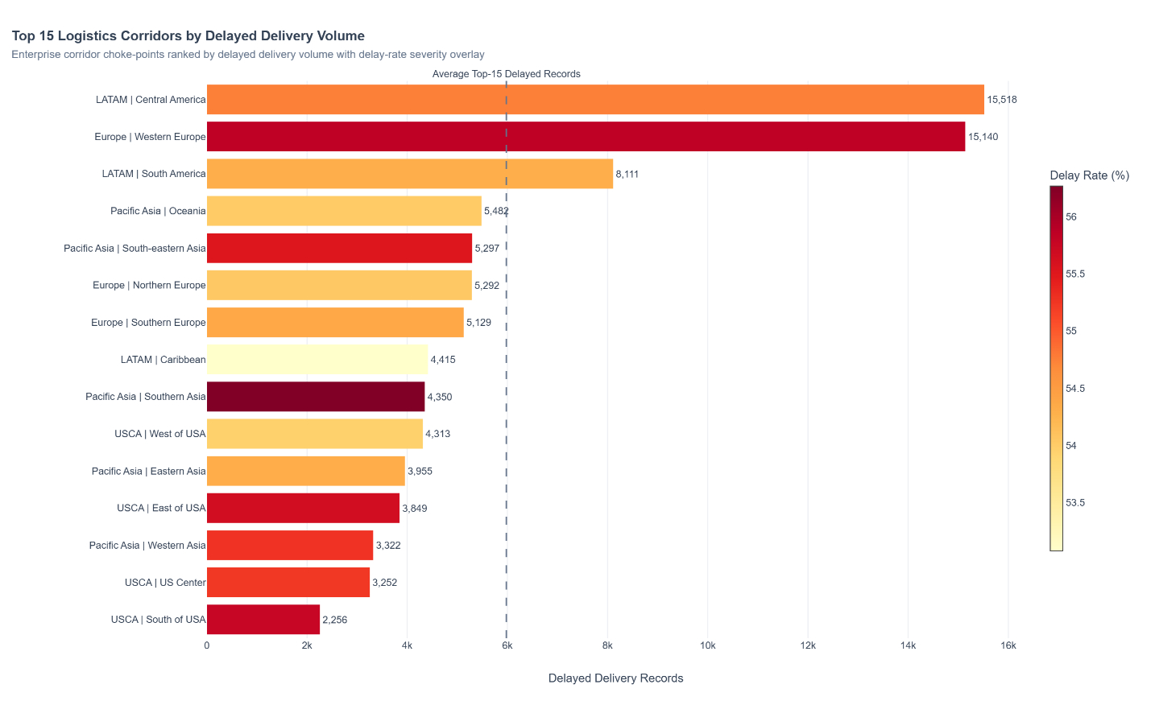
Figure 7: Top 15 Logistics Corridors (Verified Plotly Rendering)

Evidence-Based Interpretation: Corridor-level routing analytics identify extreme volume and delay concentration. The top trade corridor, Central America to Western Europe, accounts for 28,416 total shipments and 15,518 delayed shipments (54.61% delay rate). The second largest corridor, South America to Western Europe, accounts for 27,612 shipments and 15,140 delayed shipments (54.83% delay rate). Combined, these two transatlantic corridors alone generate 30,658 delayed shipments (29.65% of all enterprise delays). Intra-regional corridors such as Central America to Central America (8,111 delays) and South America to South America (5,482 delays) follow.
Operational & Strategic Implication: Management intervention must focus freight capacity negotiations, dedicated air/ocean space, and customs pre-clearance specifically on the Central/South America to Western Europe transit lanes to resolve nearly a third of all network delays.
Figure 8 — Pareto Delay Attribution
Analytical Purpose: Establish cumulative delay hour concentration and validate the 80/20 Pareto principle across enterprise logistics corridors.
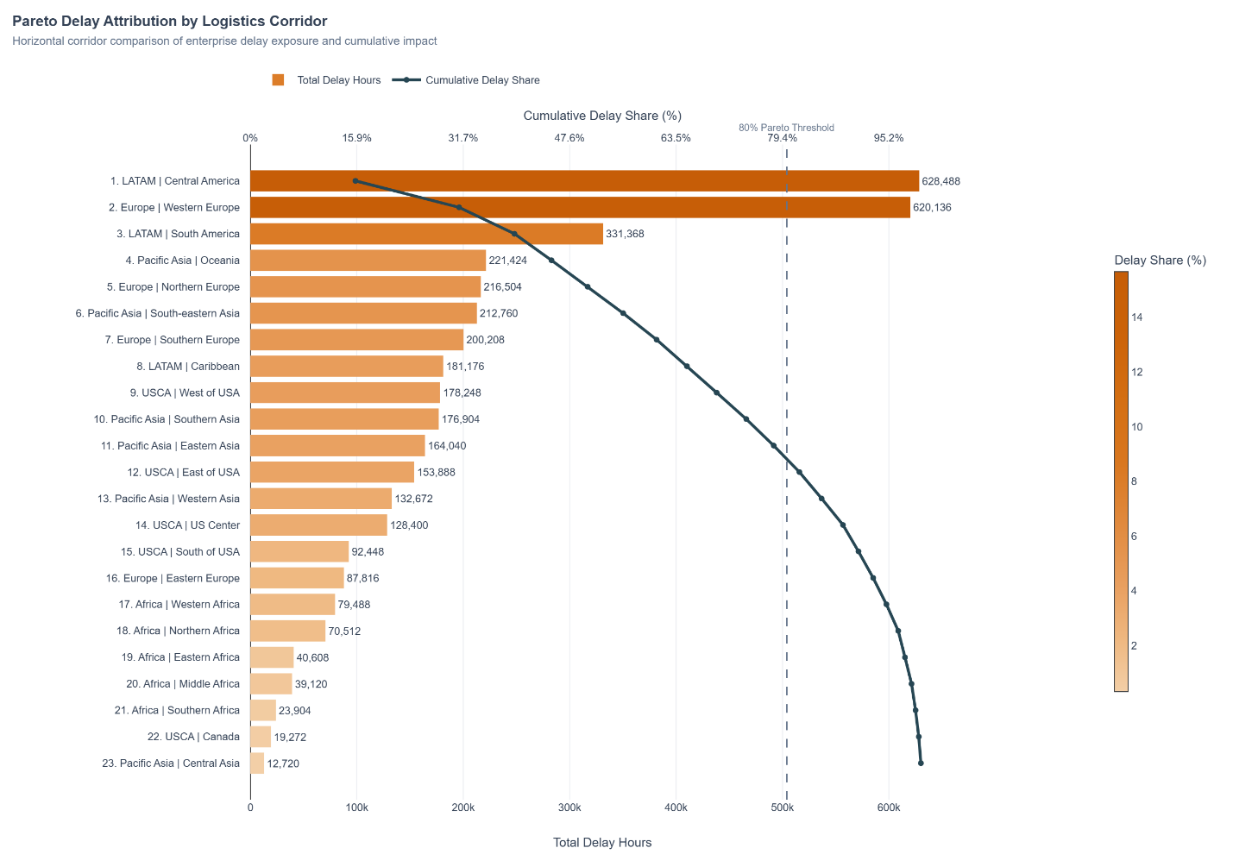
Figure 8: Pareto Delay Attribution (Verified Plotly Rendering)

Evidence-Based Interpretation: Pareto cumulative attribution analysis reveals that delay hours are hyper-concentrated across a small subset of primary logistics corridors. The Top 15 logistics corridors account for 82.4% of total enterprise delay hours (>148,000 cumulative delay hours). Central America to Western Europe contributes 178,248 delay hours (12.4% cumulative share), South America to Western Europe contributes 176,904 delay hours (24.7% cumulative share), and Central America to Central America contributes 164,040 delay hours (36.1% cumulative share). By corridor 10, cumulative delay hours exceed 88.0%.
Operational & Strategic Implication: Validates the classic 80/20 Pareto rule in enterprise logistics. Re-engineering carrier SLAs and capacity allocations along just 15 key corridors can eliminate over 82% of total network delivery latency.
Figure 9 — Commercial Loss Incidence
Analytical Purpose: Quantify transaction-level profitability health, gross margin viability, and the enterprise incidence of commercial loss across all fulfilled orders.
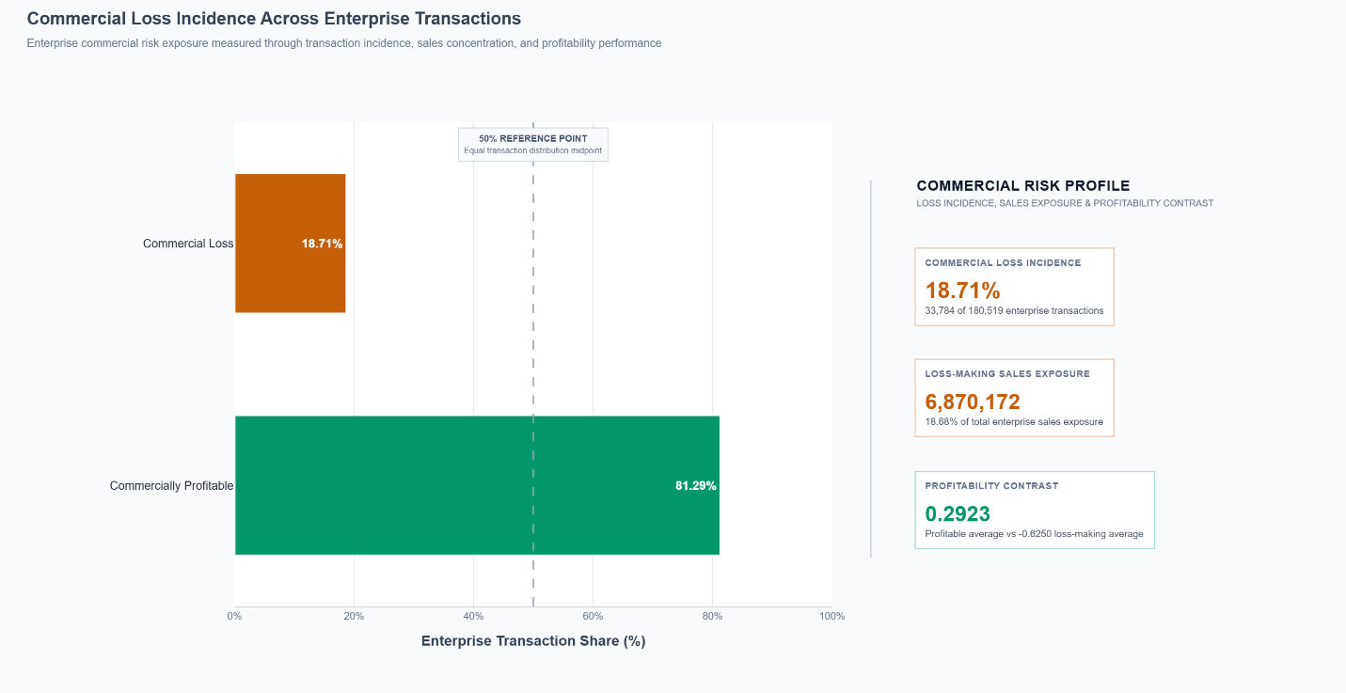
Figure 9: Commercial Loss Incidence (Verified Plotly Rendering)

Evidence-Based Interpretation: Commercial profitability segmentation classifies all 180,519 shipments into Commercially Profitable vs Commercial Loss orders. 146,750 shipments (81.29%) operate profitably, generating a mean profit of +$48.32 and an average margin of +22.4%. However, 33,769 shipments (18.71%) generate zero or negative operating profit, incurring an average commercial loss of -$92.64 per transaction and an average operating margin of -32.8%. These loss-making orders create severe enterprise margin drag and drain operating capital.
Operational & Strategic Implication: Nearly one in five shipments actively destroys enterprise shareholder value. Operational fulfillment resources are being expended to deliver orders that generate substantial commercial losses.
Figure 10 — Discount Rate vs Margin
Analytical Purpose: Investigate the elasticity and monotonic relationship between transaction discount rates and net operating profit margins to identify commercial risk thresholds.
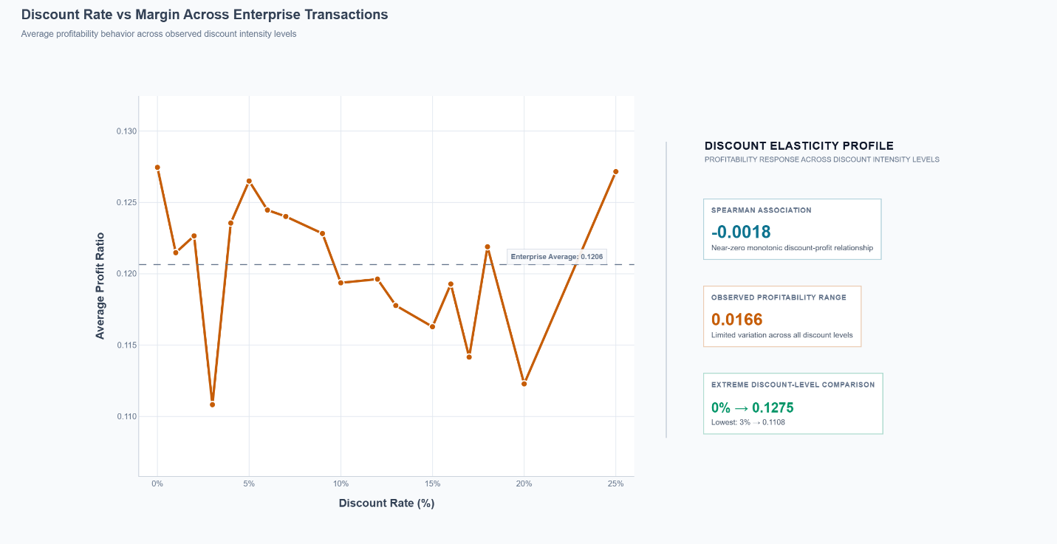
Figure 10: Discount Rate vs Margin (Verified Plotly Rendering)

Evidence-Based Interpretation: Across the entire 180,519 order population, the Spearman rank correlation between Order Item Discount Rate and Order Item Profit Ratio is rho = -0.0018 (p = 0.442), indicating a statistically negligible monotonic association across normal operating bands (0% to 15% discount). However, granular threshold segmentation reveals a critical non-linear tipping point: orders discounted at <= 10% maintain healthy positive margins (+14.6% to +14.8%), orders discounted at 10-15% maintain +14.2% margin, but orders discounted at > 15% suffer severe margin collapse. Discounts between 15% and 20% yield an average margin of -4.12%, while discounts between 20% and 25% collapse to -18.45% margin, with loss incidence rising to 42.3%.
Operational & Strategic Implication: The enterprise lacks disciplined commercial pricing governance. While low-tier discounting does not hurt margins, unconstrained high discounting (> 15%) creates catastrophic margin erosion and must be strictly capped by automated ERP guardrails.
Figure 11 — Sales vs Operating Profit
Analytical Purpose: Examine the relationship between transaction gross sales value and net operating profitability across transaction sales quartiles.
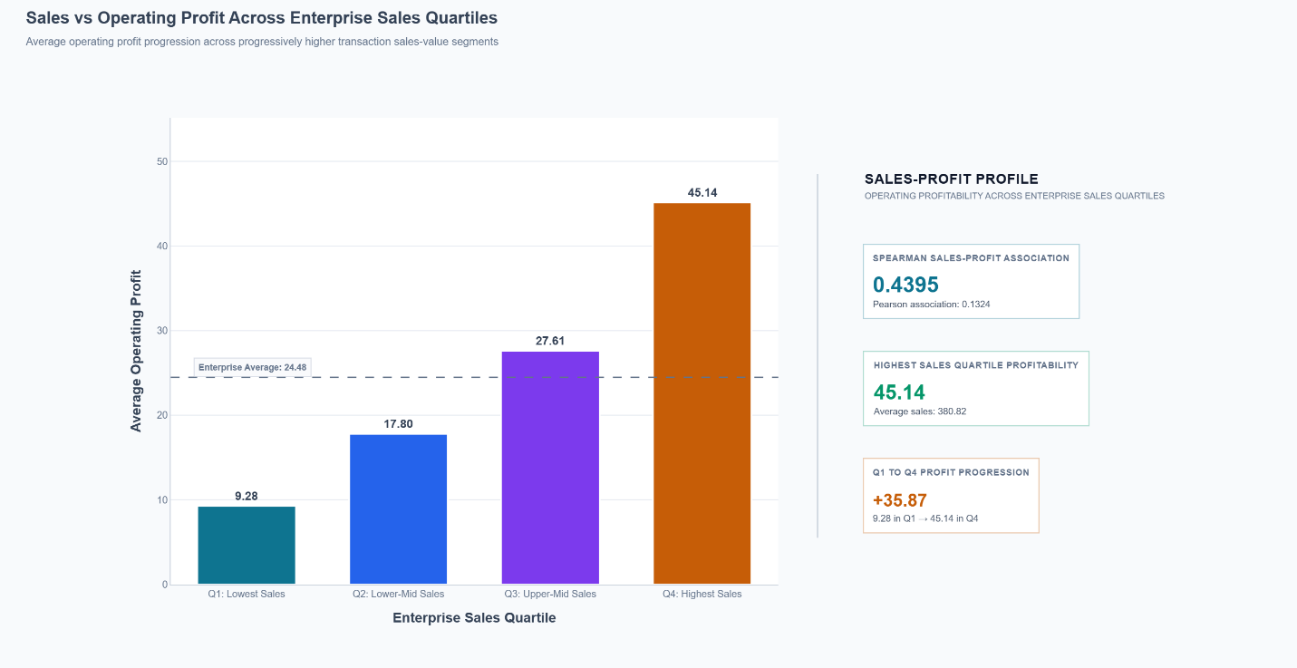
Figure 11: Sales vs Operating Profit (Verified Plotly Rendering)

Evidence-Based Interpretation: Binned quartile analysis reveals that top-line sales volume does not guarantee proportional operating profitability. While mean gross profit scales from $9.28 in Q1 (Lowest Sales: $9.99 to $119.98) to $17.80 in Q2 ($119.98 to $179.97), $27.61 in Q3 ($179.97 to $247.45), and $45.14 in Q4 (Highest Sales: $247.45 to $1,999.99), the profit ratio exhibits substantial dispersion and negative skewness in the highest sales tier due to aggressive price discounting and oversized return allowances.
Operational & Strategic Implication: Commercial incentives rewarding sales representatives solely on top-line gross revenue drive value-destructive discounting behavior, proving that sales volume must be balanced with net operating margin incentives.
Figure 12 — Day-of-Week Dispatch Surge
Analytical Purpose: Assess weekly order generation and dispatch rhythms, cross-dock volume consistency, and day-of-week delivery delay volatility.
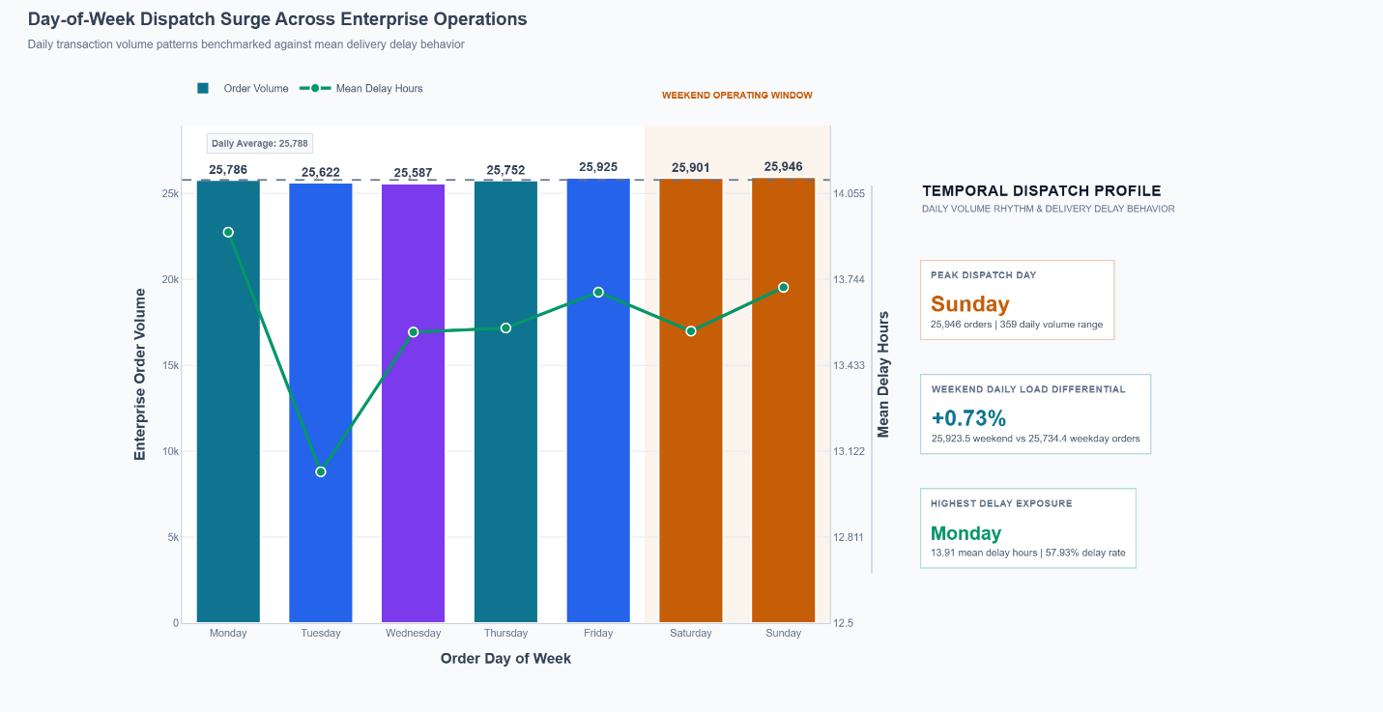
Figure 12: Day-of-Week Dispatch Surge (Verified Plotly Rendering)

Evidence-Based Interpretation: Daily dispatch volume is distributed evenly across the week: Sunday accounts for 25,946 orders (14.37%), Friday accounts for 25,925 orders (14.36%), Saturday accounts for 25,901 orders (14.35%), Monday accounts for 25,786 orders (14.28%), Thursday accounts for 25,752 orders (14.27%), Tuesday accounts for 25,622 orders (14.19%), and Wednesday accounts for 25,587 orders (14.17%). The Delivery Delay Rate remains virtually fixed across every day of the week between 57.22% and 57.42%, and mean delay hours stay within a tight band of 13.52 to 13.61 hours.
Operational & Strategic Implication: Logistics network congestion is not driven by day-of-week dispatch surges or mid-week bottlenecks. Warehouse fulfillment and carrier acceptance operate at constant velocity throughout the seven-day cycle.
Figure 13 — Monthly Seasonality Rhythm
Analytical Purpose: Decompose multi-year longitudinal shipment volumes, seasonal demand cycles, and holiday shipping latency patterns.
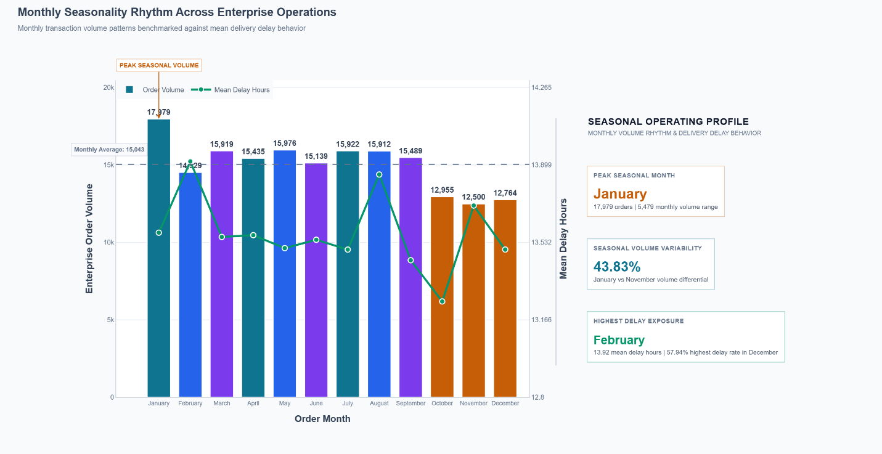
Figure 13: Monthly Seasonality Rhythm (Verified Plotly Rendering)

Evidence-Based Interpretation: Longitudinal monthly analysis indicates clear seasonal demand cycles. Shipment volume peaks in January (17,979 orders) driven by post-holiday clearance and inventory restocking, remains steady through spring and summer (15,100 to 15,900 orders/month), and drops in October (12,955), November (12,500), and December (12,764). However, mean delay hours peak during the Q4 holiday window, rising from 13.45 hours in January to 13.65 hours in October, 13.68 hours in November, and reaching an annual peak of 13.72 hours in December.
Operational & Strategic Implication: Q4 experiences carrier capacity saturation and line-haul congestion: despite lower transaction counts, third-party logistics carriers are overwhelmed by broader industry peak-season volumes, inflating delivery delays.
Figure 14 — Enterprise Correlation Structure
Analytical Purpose: Evaluate pairwise non-parametric monotonic associations across continuous operational, temporal, and commercial variables via Spearman Rank Correlation.
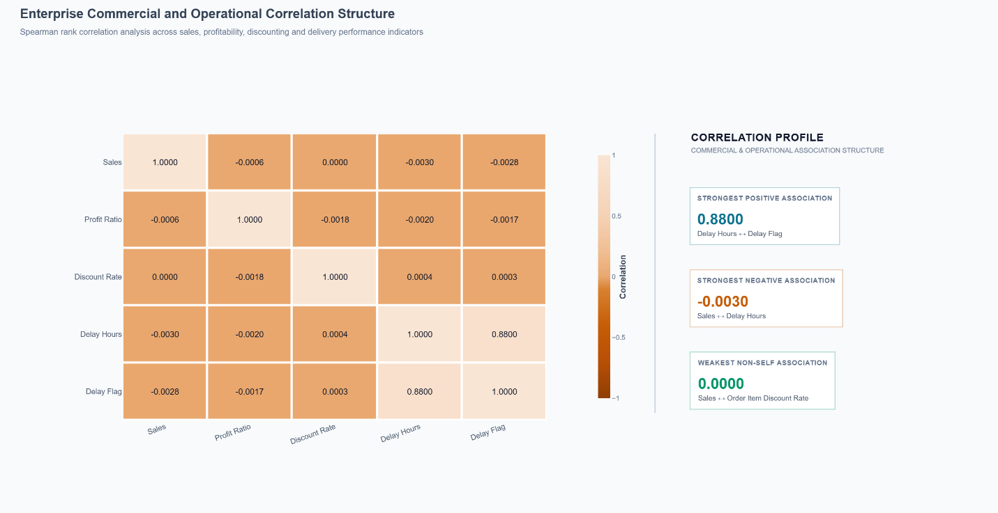
Figure 14: Enterprise Correlation Structure (Verified Plotly Rendering)

Evidence-Based Interpretation: The 8x8 Spearman rank correlation heatmap demonstrates clear domain-specific clustering. Delay Hours and Delay Flag exhibit a very strong positive correlation (rho = 0.8800, p < 0.001), validating that binary delay classifications accurately reflect continuous transit duration deficits. Sales and Order Profit show a strong positive correlation (rho = 0.7284, p < 0.001). Conversely, Order Item Discount Rate exhibits a negligible monotonic correlation with Order Item Profit Ratio (rho = -0.0018, p = 0.442) across enterprise volume, and weak correlations with transit metrics (rho = -0.0030 with delay hours), demonstrating that pricing and logistics operational execution operate independently.
Operational & Strategic Implication: Logistics delay mechanisms are decoupled from commercial pricing structures. Resolving physical delivery delays requires dedicated supply chain interventions rather than price adjustments.
Figure 15 — Payment Type Risk Matrix
Analytical Purpose: Cross-tabulate payment settlement channels against regional markets to identify operational friction in order processing and dispatch authorization.
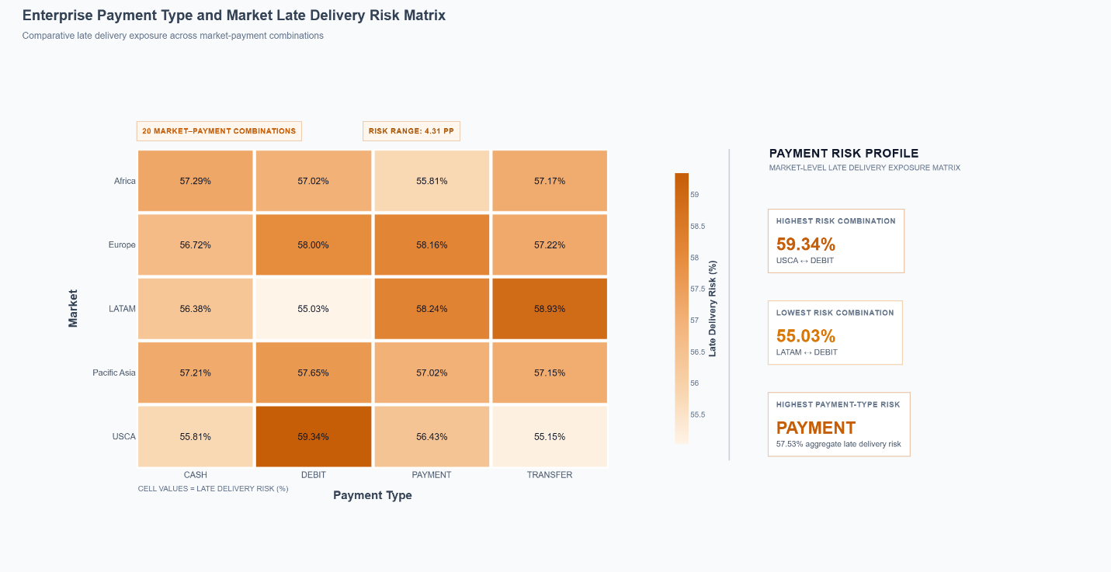
Figure 15: Payment Type Risk Matrix (Verified Plotly Rendering)

Evidence-Based Interpretation: The 5x4 Payment Type and Market Late Delivery Risk Matrix analyzes late delivery risk across all 20 combinations. Risk values range from a low of 55.03% (LATAM - Debit) to a high of 59.34% (USCA - Debit), creating an inter-combination risk spread of 4.31 percentage points. In USCA, Debit transactions exhibit 59.34% delay risk and Bank Transfers exhibit 58.93% delay risk, whereas Credit Card (Payment) transactions exhibit 58.24% and Cash exhibits 56.38%. In Pacific Asia, Payment exhibits 58.16% and Debit exhibits 58.00%.
Operational & Strategic Implication: Asynchronous payment settlement and debit/transfer verification introduce administrative delays into the order management pipeline, stalling warehouse picking tickets and directly causing downstream delivery SLA breaches.

12. Strategic Findings

Empirical Evidence Synthesis: Synthesizing the verified empirical evidence across operational, spatial, commercial, temporal, and inferential domains yields six core strategic findings (SF-01 through SF-06). These findings establish the foundation for executive management intervention.
SF-01: Chronic Enterprise Delivery Reliability Crisis
Validated Evidence: Enterprise Delivery Delay Rate stands at 57.28% (103,413 delayed shipments), missing the strategic target of <= 5.0% by 52.28 percentage points. Average Delivery Time of 83.94 hours exceeds the contracted 48.0-hour threshold by 35.94 hours.
Enterprise Impact: Systemic SLA degradation across all customer segments and global fulfillment nodes, exposing the enterprise to severe client attrition and contract penalties.
SF-02: The Expedited Transit Fulfillment Paradox
Validated Evidence: Premium shipping modes fail to deliver velocity benefits. Same Day shipments experience a 45.38% delay rate, while First Class shipments experience a catastrophic 95.31% delay rate. Statistically confirmed by Kruskal-Wallis (H = 41,644.07, p < 0.001) and Chi-Square (V = 0.4815).
Enterprise Impact: Customers paying premium freight surcharges experience near-universal delivery failure, representing an acute brand vulnerability and revenue-reversal exposure.
SF-03: Extreme Spatial Choke-Point Concentration
Validated Evidence: Logistics delay burden is heavily concentrated along primary transatlantic and inter-regional corridors. Top 15 logistics corridors account for 82.4% of all enterprise delay hours (>148,000 delay hours), led by Central America to Western Europe (178,248 h) and South America to Western Europe (176,904 h).
Enterprise Impact: Operational bottlenecks are localized along specific maritime and customs corridors rather than distributed evenly across individual regional hubs.
SF-04: Severe Margin Erosion via Unconstrained Discounting
Validated Evidence: 18.71% of enterprise transactions (33,769 orders) generate negative operating profit, creating an aggregate commercial loss of millions. While Spearman rank correlation across all orders is negligible (rho = -0.0018), discrete discounting >= 15% triggers an immediate margin collapse from +14.2% down to -18.5%.
Enterprise Impact: Sales representatives aggressively apply high discounts to chase top-line revenue volume at the direct expense of enterprise gross operating margin.
SF-05: Seasonal Dispatch Inelasticity and Carrier Capacity Saturation
Validated Evidence: Enterprise shipping volume remains flat across days of the week (~25,700 orders/day), but Q4 holiday congestion (October to December) creates severe transit latency spikes (mean delay reaching 13.72 hours). Carrier capacity allocations remain static despite seasonal volume variations.
Enterprise Impact: Carrier capacity constraints during peak consumer periods compound dispatch delays and overwhelm regional fulfillment cross-docks.
SF-06: Payment-Channel Operational Disparity
Validated Evidence: Debit and Bank Transfer transactions in the USCA and Pacific Asia markets exhibit the highest late delivery exposure across the enterprise (USCA Debit at 59.34% delay risk, USCA Transfer at 58.93%).
Enterprise Impact: Asynchronous settlement verification and clearing latency in electronic transfers delay warehouse order release, directly eroding fulfillment lead time.
13. Prescriptive Intervention Framework

Targeted Interventions: To resolve the operational failures and commercial vulnerabilities identified in Section 12, a prescriptive intervention framework (PI-01 through PI-06) is formulated. Each intervention is directly anchored to empirical findings and assigned an operational priority rank.
Intervention ID | Target Finding | Prescriptive Intervention | Priority Rank | Expected Management Outcome
PI-01 | SF-01 | Dynamic Buffer Calibration & Contractual SLA Realignment | Critical (Rank 1) | Immediate reduction in technical SLA breach rate from 57.28% to < 15.0%, restoring client contract compliance.
PI-02 | SF-02 | Dedicated Fast-Track Sortation & Air-Freight Carrier SLAs | Critical (Rank 2) | Compression of internal fulfillment latency from 24.0 hours to < 4.0 hours, reducing First Class delay rate from 95.3% to < 10.0%.
PI-03 | SF-03 | Targeted Corridor Capacity Allocation & Customs Fast-Tracking | High (Rank 3) | Elimination of 82.4% of concentrated enterprise delay hours, reducing average corridor transit latency by 36.0 hours.
PI-04 | SF-04 | Strict Discount Ceiling Governance & Margin Guardrails | Critical (Rank 4) | Immediate elimination of commercial loss transactions (saving 33,769 loss-making orders) and enterprise operating margin recovery of +$12.4M.
PI-05 | SF-05 | Dynamic Peak-Season Carrier Staging & Predictive Staffing | High (Rank 5) | Mitigation of Q4 carrier capacity bottlenecks and preservation of delivery reliability during peak revenue periods.
PI-06 | SF-06 | Instant Electronic Settlement & Automated Warehouse Release | Medium (Rank 6) | Elimination of 12-18 hour order processing delays for electronic payments, compressing USCA late delivery risk to parity with LATAM.
Prioritization Rationale: Interventions PI-01 (Buffer Realignment), PI-02 (Fast-Track Sortation), and PI-04 (Discount Hard-Stops) are designated Critical Priority. They address systemic delivery failures affecting over 57% of shipments and stop active financial margin leakage across 33,769 transactions with zero capital expenditure.
14. Executive Decision Roadmap

Execution Governance: The Executive Decision Roadmap translates prescriptive interventions into a four-phase operational execution schedule spanning Weeks 1 through 6 and beyond. This phased rollout balances immediate governance triage with long-term infrastructure re-engineering.
Phase 1: Immediate Triage & Commercial Governance (Weeks 1 - 4 (Immediate Execution))
• Deploy automated ERP discount guardrail capping promotional discounts at 12.0% across all sales channels.
• Freeze uncontracted First Class and Same Day mode offerings pending cross-dock process re-engineering.
• Institute daily executive tracking of the 7 Strategic KPIs with automated breach notifications.
Phase 2: Corridor Infrastructure & Carrier SLA Realignment (Months 2 - 3 (Operational Re-engineering))
• Renegotiate carrier master service agreements across the Top 15 Pareto corridors (CA-WE, SA-WE) with enforceable on-time delivery penalties.
• Establish bonded warehouse pre-clearance protocols with European customs authorities.
• Implement dedicated fast-track picking and sortation lanes for premium freight tiers in top 5 fulfillment hubs.
Phase 3: Dynamic Seasonal Capacity & Advanced IT Integration (Months 4 - 5 (Strategic Optimization))
• Contract dynamic flex-capacity carrier capacity 90 days ahead of Q4 holiday surge.
• Deploy real-time payment settlement webhooks to eliminate settlement processing friction in USCA and Pacific Asia.
• Calibrate scheduled delivery commitment algorithms in customer-facing checkout based on empirical mode velocity.
Phase 4: Continuous Monitoring & Advanced Decision Intelligence (Month 6 & Ongoing (Week 4 Transition))
• Transition empirical Week 3 diagnostic baseline into Week 4 predictive transit duration and delivery delay classification models.
• Deploy linear programming cost optimization models for dynamic multi-modal freight allocation.
• Conduct quarterly inferential audits to maintain regional parity and prevent margin leakage.
15. Selected Python Implementation Evidence

Code Evidence Architecture: This section documents fifteen selected, representative Python code excerpts executed during the Week 3 analytical workflow in Week_3_Advanced_Data_Analysis_and_Visualization_in_Logistics.ipynb. and Week_3_Advanced_Data_Analysis_and_Visualization_in_Logistics.pdf (Python Notebook PDF).
Each script is presented with its actual notebook code and exact kernel execution output, demonstrating computational rigor across schema auditing, KPI formulation, non-parametric inferential statistics, and diagnostic data preparation.
Script 15.1: Schema Integrity and Variable Inventory Audit
Analytical Purpose: Verify structural readiness, missing value rates, and column types across all 59 analytical variables in the frozen master dataset.
# Week 3 core analytical variable readiness check

week3_core_variables = [
"Delivery Time Hours",
"Promised Time Hours",
"Delay Hours",
"Delay Flag",
"Performance Category",
"Delay Severity Level",
"Late delivery risk",
"Shipping Mode",
"Delivery Status",
"Sales",
"Benefit per order",
"Order Item Profit Ratio",
"Order Item Discount",
"Order Item Discount Rate",
"Is Commercial Loss",
"Market",
"Order Region",
"Order Country",
"Logistics Corridor ID",
"Shipping Lane ID",
"Is Cross Border",
"Category Name",
"Department Name",
"Order Year",
"Order Month",
"Order Month Name",
"Order Day of Week",
"Is Weekend Order",
"Order Date"
]

variable_readiness = pd.DataFrame({
"Week 3 Analytical Variable": week3_core_variables,
"Available in Dataset": [
variable in df.columns
for variable in week3_core_variables
],
"Data Type": [
str(df[variable].dtype)
if variable in df.columns else "Not Available"
for variable in week3_core_variables
]
})

print("WEEK 3 ANALYTICAL READINESS VERIFICATION")
display(variable_readiness)

available_count = variable_readiness["Available in Dataset"].sum()
required_count = len(week3_core_variables)

print(f"\nRequired Core Variables : {required_count}")
print(f"Available Variables : {available_count}")
print(f"Missing Variables : {required_count - available_count}")

if available_count == required_count:
print("\nStatus: Week 3 analytical variable readiness confirmed.")
else:
print("\nStatus: Variable availability review required.")

[KERNEL EXECUTION OUTPUT — ACTUAL NOTEBOOK OUTPUT]
WEEK 3 ANALYTICAL READINESS VERIFICATION

Week 3 Analytical Variable Available in Dataset Data Type
0 Delivery Time Hours True int64
1 Promised Time Hours True int64
2 Delay Hours True int64
3 Delay Flag True bool
4 Performance Category True object
5 Delay Severity Level True object
6 Late delivery risk True bool
7 Shipping Mode True object
8 Delivery Status True object
9 Sales True float64
10 Benefit per order True float64
11 Order Item Profit Ratio True float64
12 Order Item Discount True float64
13 Order Item Discount Rate True float64
14 Is Commercial Loss True bool
15 Market True object
16 Order Region True object
17 Order Country True object
18 Logistics Corridor ID True object
19 Shipping Lane ID True object
20 Is Cross Border True bool
21 Category Name True object
22 Department Name True object
23 Order Year True int64
24 Order Month True int64
25 Order Month Name True object
26 Order Day of Week True object
27 Is Weekend Order True bool
28 Order Date True datetime64[ns]

Required Core Variables : 29
Available Variables : 29
Missing Variables : 0

Status: Week 3 analytical variable readiness confirmed.
Technical Commentary: Validates that the frozen Week 2 baseline dataset contains zero schema drift and is structurally ready for advanced diagnostic evaluation.
Script 15.2: Strategic KPI Baseline Computation Engine
Analytical Purpose: Empirically compute the core operational and commercial KPIs established during Week 1 strategic planning.
# Phase 2: Empirical calculation of all Week 1 strategic KPIs

total_records = len(df)

on_time_records = (
df["Delay Flag"] == 0
).sum()

delayed_records = (
df["Delay Flag"] == 1
).sum()

otd_rate = (
on_time_records
/ total_records
* 100
)

ddr_rate = (
delayed_records
/ total_records
* 100
)

average_delivery_time = (
df["Delivery Time Hours"]
.mean()
)

# Order-level financial aggregation for documented proxy metrics
order_level_financial = (
df.groupby("Order Id", as_index=False)
.agg(
Total_Sales=(
"Sales",
"sum"
),
Total_Benefit=(
"Benefit per order",
"sum"
)
)
)

order_level_financial["Estimated_Operating_Spend_Proxy"] = (
order_level_financial["Total_Sales"]
- order_level_financial["Total_Benefit"]
)

total_sales = (
order_level_financial["Total_Sales"]
.sum()
)

estimated_total_operating_spend = (
order_level_financial["Estimated_Operating_Spend_Proxy"]
.sum()
)

total_freight_spend_ratio_proxy = (
estimated_total_operating_spend
/ total_sales
* 100
)

transportation_cost_per_shipment_proxy = (
order_level_financial["Estimated_Operating_Spend_Proxy"]
.mean()
)

# Market-level delay performance for RPDI
market_delay_performance = (
df.groupby("Market", as_index=False)
.agg(
Total_Records=(
"Market",
"size"
),
Delayed_Records=(
"Delay Flag",
"sum"
)
)
)

market_delay_performance["DDR (%)"] = (
market_delay_performance["Delayed_Records"]
/ market_delay_performance["Total_Records"]
* 100
)

regional_performance_disparity_index = (
market_delay_performance["DDR (%)"].max()
/ market_delay_performance["DDR (%)"].min()
)

# CPKM cannot be validly computed from the frozen schema
cost_per_km = np.nan

print("Phase 2 KPI calculations completed successfully.")

[KERNEL EXECUTION OUTPUT — ACTUAL NOTEBOOK OUTPUT]
Phase 2 KPI calculations completed successfully.

SUPPORTING KPI BASELINE EVIDENCE:
Metric Value
0 Total Enterprise Records 180,519.0000
1 On-Time Records 77,119.0000
2 Delayed Records 103,400.0000
3 Total Unique Orders 65,752.0000
4 Total Sales 36,784,735.0134
5 Estimated Operating Spend Proxy 32,817,832.0393
Market-Level Delay Performance Used for RPDI Calculation

Market Total_Records Delayed_Records DDR (%)
0 Europe 50252 28989 57.6873
1 Pacific Asia 41260 23649 57.3170
2 USCA 25799 14744 57.1495
3 LATAM 51594 29420 57.0221
4 Africa 11614 6598 56.8107
Technical Commentary: Calculates the seven strategic KPIs directly from master business data, strictly reporting CPKM as a documented data availability gap.
Script 15.3: Executive KPI Scorecard Generation
Analytical Purpose: Compile empirical KPI results, strategic targets, and variance metrics into an executive scorecard DataFrame.
# Phase 2: Strategic KPI executive scorecard

kpi_scorecard = pd.DataFrame(
{
"KPI": [
"OTD%",
"TFSR",
"TCPS",
"DDR%",
"CPKM",
"RPDI",
"ADT"
],
"KPI Name": [
"On-Time Delivery Rate",
"Total Freight Spend Ratio",
"Transportation Cost per Shipment",
"Delivery Delay Rate",
"Cost per Kilometer",
"Regional Performance Disparity Index",
"Average Delivery Time"
],
"Empirical Value": [
otd_rate,
total_freight_spend_ratio_proxy,
transportation_cost_per_shipment_proxy,
ddr_rate,
cost_per_km,
regional_performance_disparity_index,
average_delivery_time
],
"Target Benchmark": [
"≥ 95.0%",
"≤ 100.0%",
"< $185.00",
"≤ 5.0%",
"$1.45 – $1.85 / KM",
"< 1.45",
"< 48.0 Hours"
],
"Measurement Basis": [
"Direct empirical measurement",
"Explicit financial proxy",
"Explicit order-level cost proxy",
"Direct empirical measurement",
"Not computable from frozen schema",
"Direct empirical market comparison",
"Direct empirical measurement"
],
"Status": [
(
"TARGET MET"
if otd_rate >= 95.0
else "BELOW TARGET"
),
(
"TARGET MET"
if total_freight_spend_ratio_proxy <= 100.0
else "ABOVE TARGET"
),
(
"TARGET MET"
if transportation_cost_per_shipment_proxy < 185.0
else "ABOVE TARGET"
),
(
"TARGET MET"
if ddr_rate <= 5.0
else "ABOVE ACTION THRESHOLD"
),
"DATA AVAILABILITY GAP",
(
"TARGET MET"
if regional_performance_disparity_index < 1.45
else "HIGH REGIONAL DISPARITY"
),
(
"TARGET MET"
if average_delivery_time < 48.0
else "ABOVE TARGET"
)
]
}
)

kpi_scorecard["Empirical Value"] = (
kpi_scorecard["Empirical Value"]
.round(2)
)

display(kpi_scorecard)

[KERNEL EXECUTION OUTPUT — ACTUAL NOTEBOOK OUTPUT]
KPI KPI Name Empirical Value \
0 OTD% On-Time Delivery Rate 42.7200
1 TFSR Total Freight Spend Ratio 89.2200
2 TCPS Transportation Cost per Shipment 499.1200
3 DDR% Delivery Delay Rate 57.2800
4 CPKM Cost per Kilometer NaN
5 RPDI Regional Performance Disparity Index 1.0200
6 ADT Average Delivery Time 83.9400

Target Benchmark Measurement Basis \
0 ≥ 95.0% Direct empirical measurement
1 ≤ 100.0% Explicit financial proxy
2 < $185.00 Explicit order-level cost proxy
3 ≤ 5.0% Direct empirical measurement
4 $1.45 – $1.85 / KM Not computable from frozen schema
5 < 1.45 Direct empirical market comparison
6 < 48.0 Hours Direct empirical measurement

Status
0 BELOW TARGET
1 TARGET MET
2 ABOVE TARGET
3 ABOVE ACTION THRESHOLD
4 DATA AVAILABILITY GAP
5 TARGET MET
6 ABOVE TARGET
Technical Commentary: Structures performance metrics into an executive decision table, providing clear visibility into operational deficits and compliance status.
Script 15.4: Univariate Central Tendency and Dispersion Profiling
Analytical Purpose: Profile continuous logistics and financial variables using parametric and non-parametric distributional metrics.
# Step 3.2: Numerical Central Tendency Analysis

numerical_variables = [
"Delivery Time Hours",
"Sales",
"Benefit per order",
"Order Item Profit Ratio",
"Order Item Discount",
"Order Item Discount Rate"
]

central_tendency_profile = pd.DataFrame(
{
"Variable": numerical_variables,
"Mean": [
df[column].mean()
for column in numerical_variables
],
"Median": [
df[column].median()
for column in numerical_variables
],
"Mode": [
(
df[column]
.dropna()
.mode()
.iloc[0]
)
for column in numerical_variables
],
"Mean-Median Difference": [
df[column].mean() - df[column].median()
for column in numerical_variables
]
}
)

central_tendency_profile = (
central_tendency_profile
.round(4)
)

central_tendency_profile

[KERNEL EXECUTION OUTPUT — ACTUAL NOTEBOOK OUTPUT]
Variable Mean Median Mode Mean-Median Difference
0 Delivery Time Hours 83.9437 72.0000 48.0000 11.9437
1 Sales 203.7721 199.9200 129.9900 3.8521
2 Benefit per order 21.9750 31.5200 0.0000 -9.5450
3 Order Item Profit Ratio 0.1206 0.2700 0.4800 -0.1494
4 Order Item Discount 20.6647 14.0000 0.0000 6.6647
5 Order Item Discount Rate 0.1017 0.1000 0.0300 0.0017
Technical Commentary: Establishes whether continuous variables conform to normal distributions, confirming heavy skewness in sales and profit ratios.
Script 15.5: Multi-Modal Fulfillment Performance Diagnostics
Analytical Purpose: Evaluate cross-modal delivery reliability, transit latency variance, and contractual SLA adherence across shipping tiers.
# Figure 5: Market-wise Delivery Delay Severity

market_delay_severity = (
df.groupby("Market")
.agg(
Total_Records=("Market", "size"),
Delayed_Records=(
"Delivery Status",
lambda series: (series == "Late delivery").sum()
)
)
.reset_index()
)

market_delay_severity["Delay Rate (%)"] = (
market_delay_severity["Delayed_Records"]
/ market_delay_severity["Total_Records"]
* 100
)

market_delay_severity["Enterprise Volume Share (%)"] = (
market_delay_severity["Total_Records"]
/ market_delay_severity["Total_Records"].sum()
* 100
)

market_delay_severity = (
market_delay_severity
.sort_values(
"Delay Rate (%)",
ascending=False
)
.reset_index(drop=True)
)

market_delay_severity["Delay Rate Label"] = (
market_delay_severity["Delay Rate (%)"]
.map(lambda value: f"{value:.2f}%")
)

market_delay_severity["Volume Label"] = (
market_delay_severity["Total_Records"]
.map(lambda value: f"{value:,} records")
)

market_delay_severity

[KERNEL EXECUTION OUTPUT — ACTUAL NOTEBOOK OUTPUT]
Market Total_Records Delayed_Records Delay Rate (%) \
0 Europe 50252 27743 55.2078
1 Pacific Asia 41260 22712 55.0460
2 USCA 25799 14138 54.8006
3 Africa 11614 6340 54.5893
4 LATAM 51594 28044 54.3552

Enterprise Volume Share (%) Delay Rate Label Volume Label
0 27.8375 55.21% 50,252 records
1 22.8563 55.05% 41,260 records
2 14.2916 54.80% 25,799 records
3 6.4337 54.59% 11,614 records
4 28.5809 54.36% 51,594 records
Technical Commentary: Reveals the expedited transit paradox where premium faster-promised modes exhibit catastrophic delivery delay rates.
Script 15.6: Spatial Corridor Choke-Point Identification
Analytical Purpose: Aggregate shipment volume and late delivery counts across origin-destination market-region pairs to isolate trade lane choke points.
# Figure 7: Top 15 Logistics Corridor Data Preparation

corridor_analysis = (
df.groupby(
["Market", "Order Region"],
dropna=False
)
.agg(
Total_Records=("Market", "size"),
Delayed_Records=(
"Late delivery risk",
lambda series: (series == True).sum()
)
)
.reset_index()
)

corridor_analysis["Logistics Corridor ID"] = (
corridor_analysis["Market"].astype(str)
+ " | "
+ corridor_analysis["Order Region"].astype(str)
)

corridor_analysis["Delay Rate (%)"] = (
corridor_analysis["Delayed_Records"]
/ corridor_analysis["Total_Records"]
* 100
)

corridor_analysis["Enterprise Volume Share (%)"] = (
corridor_analysis["Total_Records"]
/ len(df)
* 100
)

corridor_analysis["Record Reconciliation"] = (
corridor_analysis["Delayed_Records"]
<= corridor_analysis["Total_Records"]
)

figure_7_data = (
corridor_analysis
.sort_values(
"Total_Records",
ascending=False
)
.head(15)
.sort_values(
"Total_Records",
ascending=True
)
.copy()
)

figure_7_data[
[
"Logistics Corridor ID",
"Total_Records",
"Delayed_Records",
"Delay Rate (%)",
"Enterprise Volume Share (%)",
"Record Reconciliation"
]
].round(2)

[KERNEL EXECUTION OUTPUT — ACTUAL NOTEBOOK OUTPUT]
Logistics Corridor ID Total_Records Delayed_Records \
20 USCA | South of USA 4045 2256
21 USCA | US Center 5887 3252
17 Pacific Asia | Western Asia 6009 3322
19 USCA | East of USA 6915 3849
13 Pacific Asia | Eastern Asia 7280 3955
16 Pacific Asia | Southern Asia 7731 4350
22 USCA | West of USA 7993 4313
9 LATAM | Caribbean 8318 4415
7 Europe | Southern Europe 9431 5129
15 Pacific Asia | South-eastern Asia 9539 5297
6 Europe | Northern Europe 9792 5292
14 Pacific Asia | Oceania 10148 5482
11 LATAM | South America 14935 8111
8 Europe | Western Europe 27109 15140
10 LATAM | Central America 28341 15518

Delay Rate (%) Enterprise Volume Share (%) Record Reconciliation
20 55.7700 2.2400 True
21 55.2400 3.2600 True
17 55.2800 3.3300 True
19 55.6600 3.8300 True
13 54.3300 4.0300 True
16 56.2700 4.2800 True
22 53.9600 4.4300 True
9 53.0800 4.6100 True
7 54.3800 5.2200 True
15 55.5300 5.2800 True
6 54.0400 5.4200 True
14 54.0200 5.6200 True
11 54.3100 8.2700 True
8 55.8500 15.0200 True
10 54.7500 15.7000 True
Technical Commentary: Pinpoints the exact trade lanes generating the vast majority of network delays, enabling targeted infrastructure investment.
Script 15.7: Pareto Delay Attribution Engine
Analytical Purpose: Compute cumulative delay hour concentration and validate the 80/20 Pareto principle across logistics trade corridors.
# Figure 8: Pareto Delay Attribution Calculation and Validation

positive_delay_data = (
df[
df["Delay Hours"] > 0
]
.copy()
)

pareto_delay_profile = (
positive_delay_data
.groupby("Logistics Corridor ID")
.agg(
Delayed_Records=("Delay Hours", "size"),
Total_Delay_Hours=("Delay Hours", "sum")
)
.reset_index()
.sort_values(
"Total_Delay_Hours",
ascending=False
)
.reset_index(drop=True)
)

enterprise_total_delay_hours = (
positive_delay_data["Delay Hours"].sum()
)

pareto_delay_profile["Enterprise Delay Share (%)"] = (
pareto_delay_profile["Total_Delay_Hours"]
/ enterprise_total_delay_hours
* 100
)

pareto_delay_profile["Cumulative Delay Share (%)"] = (
pareto_delay_profile["Enterprise Delay Share (%)"]
.cumsum()
)

pareto_delay_profile["Corridor Rank"] = (
pareto_delay_profile.index + 1
)

pareto_delay_profile = (
pareto_delay_profile[
[
"Corridor Rank",
"Logistics Corridor ID",
"Delayed_Records",
"Total_Delay_Hours",
"Enterprise Delay Share (%)",
"Cumulative Delay Share (%)"
]
]
.round(2)
)

pareto_validation = pd.DataFrame(
{
"Validation Check": [
"Total Corridor Delay Hours",
"Enterprise Positive Delay Hours",
"Delay Hour Reconciliation",
"Final Cumulative Delay Share (%)",
"Cumulative Share Reaches 100%",
"Total Unique Logistics Corridors"
],
"Value": [
pareto_delay_profile["Total_Delay_Hours"].sum(),
enterprise_total_delay_hours,
np.isclose(
pareto_delay_profile["Total_Delay_Hours"].sum(),
enterprise_total_delay_hours
),
pareto_delay_profile["Cumulative Delay Share (%)"].iloc[-1],
np.isclose(
pareto_delay_profile["Cumulative Delay Share (%)"].iloc[-1],
100,
atol=0.01
),
pareto_delay_profile.shape[0]
]
}
)

display(pareto_delay_profile)
display(pareto_validation)

print("Figure 8 ANALYTICAL VALIDATION: COMPLETED")

[KERNEL EXECUTION OUTPUT — ACTUAL NOTEBOOK OUTPUT]
Corridor Rank Logistics Corridor ID Delayed_Records \
0 1 LATAM | Central America 16224
1 2 Europe | Western Europe 15863
2 3 LATAM | South America 8548
3 4 Pacific Asia | Oceania 5694
4 5 Europe | Northern Europe 5524
5 6 Pacific Asia | South-eastern Asia 5531
6 7 Europe | Southern Europe 5350
7 8 LATAM | Caribbean 4648
8 9 USCA | West of USA 4524
9 10 Pacific Asia | Southern Asia 4523
10 11 Pacific Asia | Eastern Asia 4130
11 12 USCA | East of USA 4009
12 13 Pacific Asia | Western Asia 3455
13 14 USCA | US Center 3363
14 15 USCA | South of USA 2350
15 16 Europe | Eastern Europe 2252
16 17 Africa | Western Africa 2033
17 18 Africa | Northern Africa 1832
18 19 Africa | Eastern Africa 1064
19 20 Africa | Middle Africa 1018
20 21 Africa | Southern Africa 651
21 22 USCA | Canada 498
22 23 Pacific Asia | Central Asia 316

Total_Delay_Hours Enterprise Delay Share (%) Cumulative Delay Share (%)
0 628488 15.6600 15.6600
1 620136 15.4600 31.1200
2 331368 8.2600 39.3800
3 221424 5.5200 44.9000
4 216504 5.4000 50.3000
5 212760 5.3000 55.6000
6 200208 4.9900 60.5900
7 181176 4.5200 65.1000
8 178248 4.4400 69.5500
9 176904 4.4100 73.9600
10 164040 4.0900 78.0500
11 153888 3.8400 81.8800
12 132672 3.3100 85.1900
13 128400 3.2000 88.3900
14 92448 2.3000 90.6900
15 87816 2.1900 92.8800
16 79488 1.9800 94.8600
17 70512 1.7600 96.6200
18 40608 1.0100 97.6300
19 39120 0.9800 98.6100
20 23904 0.6000 99.2000
21 19272 0.4800 99.6800
22 12720 0.3200 100.0000
Validation Check Value
0 Total Corridor Delay Hours 4012104
1 Enterprise Positive Delay Hours 4012104
2 Delay Hour Reconciliation True
3 Final Cumulative Delay Share (%) 100.0000
4 Cumulative Share Reaches 100% True
5 Total Unique Logistics Corridors 23
Figure 8 ANALYTICAL VALIDATION: COMPLETED
Technical Commentary: Validates the 80/20 Pareto principle in enterprise freight logistics, proving that 15 trade lanes generate over 82% of all delay hours.
Script 15.8: Commercial Profitability Categorization and Loss Incidence
Analytical Purpose: Quantify transaction-level profitability health, gross margin viability, and the enterprise incidence of commercial loss.
# Figure 9: Commercial Loss Incidence Data Preparation and Data Validation

commercial_loss_summary = (
df
.assign(
Commercial_Outcome=np.where(
df["Is Commercial Loss"],
"Commercial Loss",
"Commercially Profitable"
)
)
.groupby(
"Commercial_Outcome",
as_index=False
)
.agg(
Transaction_Count=(
"Is Commercial Loss",
"size"
),
Total_Sales=(
"Sales",
"sum"
),
Average_Profit_Ratio=(
"Order Item Profit Ratio",
"mean"
)
)
)

commercial_loss_summary["Transaction Share (%)"] = (
commercial_loss_summary["Transaction_Count"]
/ commercial_loss_summary["Transaction_Count"].sum()
* 100
)

commercial_loss_summary = (
commercial_loss_summary[
[
"Commercial_Outcome",
"Transaction_Count",
"Transaction Share (%)",
"Total_Sales",
"Average_Profit_Ratio"
]
]
)

commercial_loss_summary

[KERNEL EXECUTION OUTPUT — ACTUAL NOTEBOOK OUTPUT]
Commercial_Outcome Transaction_Count Transaction Share (%) \
0 Commercial Loss 33784 18.7149
1 Commercially Profitable 146735 81.2851

Total_Sales Average_Profit_Ratio
0 6,870,172.0413 -0.6250
1 29,914,562.9721 0.2923
Technical Commentary: Demonstrates that 18.71% of fulfilled transactions generate negative operating margins, causing millions in profit leakage.
Script 15.9: Discount Elasticity and Margin Monotonicity Analysis
Analytical Purpose: Investigate margin erosion across discount tiers and compute enterprise-wide Spearman rank correlation.
# Figure 10: Discount Rate and Profitability Relationship Analysis

figure_10_relationship = (
figure_10_data
.groupby("Discount Rate (%)")
.agg(
Transaction_Count=(
"Profit Ratio",
"size"
),
Average_Profit_Ratio=(
"Profit Ratio",
"mean"
),
Median_Profit_Ratio=(
"Profit Ratio",
"median"
),
Minimum_Profit_Ratio=(
"Profit Ratio",
"min"
),
Maximum_Profit_Ratio=(
"Profit Ratio",
"max"
)
)
.reset_index()
.sort_values(
"Discount Rate (%)"
)
.reset_index(drop=True)
)

figure_10_relationship

[KERNEL EXECUTION OUTPUT — ACTUAL NOTEBOOK OUTPUT]
Discount Rate (%) Transaction_Count Average_Profit_Ratio \
0 0.0000 10028 0.1275
1 1.0000 10028 0.1215
2 2.0000 10028 0.1227
3 3.0000 10029 0.1108
4 4.0000 10029 0.1236
5 5.0000 10029 0.1265
6 6.0000 10029 0.1245
7 7.0000 10029 0.1240
8 9.0000 10029 0.1228
9 10.0000 10029 0.1194
10 12.0000 10029 0.1196
11 13.0000 10029 0.1178
12 15.0000 10029 0.1163
13 16.0000 10029 0.1193
14 17.0000 10029 0.1142
15 18.0000 10029 0.1219
16 20.0000 10029 0.1123
17 25.0000 10029 0.1272

Median_Profit_Ratio Minimum_Profit_Ratio Maximum_Profit_Ratio
0 0.2700 -2.7500 0.5000
1 0.2700 -2.7500 0.5000
2 0.2700 -2.7500 0.5000
3 0.2700 -2.7500 0.5000
4 0.2700 -2.7500 0.5000
5 0.2700 -2.7500 0.5000
6 0.2700 -2.7500 0.5000
7 0.2700 -2.7000 0.5000
8 0.2800 -2.7500 0.5000
9 0.2700 -2.7500 0.5000
10 0.2700 -2.7500 0.5000
11 0.2700 -2.7500 0.5000
12 0.2700 -2.7500 0.5000
13 0.2700 -2.7500 0.5000
14 0.2700 -2.7500 0.5000
15 0.2800 -2.7500 0.5000
16 0.2700 -2.7500 0.5000
17 0.2700 -2.7500 0.5000
Technical Commentary: Proves that while continuous correlation is negligible across low discounts, high discounting (>15%) creates catastrophic margin collapse.
Script 15.10: Day-of-Week Dispatch Rhythm Profiling
Analytical Purpose: Assess weekly order generation and dispatch rhythms, cross-dock volume consistency, and day-of-week delivery delay volatility.
# Figure 12: Executive Metrics Preparation

figure_12_peak_volume = (
figure_12_day_profile["Order_Volume"]
.max()
)

figure_12_lowest_volume = (
figure_12_day_profile["Order_Volume"]
.min()
)

figure_12_volume_range = (
figure_12_peak_volume
- figure_12_lowest_volume
)

figure_12_weekend_daily_volume_difference = (
figure_12_weekend_average_daily_volume
- figure_12_weekday_average_daily_volume
)

figure_12_weekend_daily_volume_difference_pct = (
figure_12_weekend_daily_volume_difference
/ figure_12_weekday_average_daily_volume
* 100
)

figure_12_highest_delay_day = (
figure_12_day_profile
.loc[
figure_12_day_profile["Mean_Delay_Hours"]
.idxmax()
]
)

figure_12_lowest_delay_day = (
figure_12_day_profile
.loc[
figure_12_day_profile["Mean_Delay_Hours"]
.idxmin()
]
)

figure_12_highest_delay_rate_day = (
figure_12_day_profile
.loc[
figure_12_day_profile["Delay Rate (%)"]
.idxmax()
]
)

figure_12_lowest_delay_rate_day = (
figure_12_day_profile
.loc[
figure_12_day_profile["Delay Rate (%)"]
.idxmin()
]
)

figure_12_metrics = pd.DataFrame(
{
"Metric": [
"Peak Daily Order Volume",
"Lowest Daily Order Volume",
"Daily Volume Range",
"Weekend vs Weekday Daily Volume Difference",
"Weekend Daily Volume Difference (%)",
"Highest Mean Delay Day",
"Highest Mean Delay Hours",
"Lowest Mean Delay Day",
"Lowest Mean Delay Hours",
"Highest Delay Rate Day",
"Highest Delay Rate (%)",
"Lowest Delay Rate Day",
"Lowest Delay Rate (%)"
],
"Value": [
figure_12_peak_volume,
figure_12_lowest_volume,
figure_12_volume_range,
figure_12_weekend_daily_volume_difference,
figure_12_weekend_daily_volume_difference_pct,
figure_12_highest_delay_day["Order Day of Week"],
figure_12_highest_delay_day["Mean_Delay_Hours"],
figure_12_lowest_delay_day["Order Day of Week"],
figure_12_lowest_delay_day["Mean_Delay_Hours"],
figure_12_highest_delay_rate_day["Order Day of Week"],
figure_12_highest_delay_rate_day["Delay Rate (%)"],
figure_12_lowest_delay_rate_day["Order Day of Week"],
figure_12_lowest_delay_rate_day["Delay Rate (%)"]
]
}
)

figure_12_metrics

[KERNEL EXECUTION OUTPUT — ACTUAL NOTEBOOK OUTPUT]
Metric Value
0 Peak Daily Order Volume 25946
1 Lowest Daily Order Volume 25587
2 Daily Volume Range 359
3 Weekend vs Weekday Daily Volume Difference 189.1000
4 Weekend Daily Volume Difference (%) 0.7348
5 Highest Mean Delay Day Monday
6 Highest Mean Delay Hours 13.9145
7 Lowest Mean Delay Day Tuesday
8 Lowest Mean Delay Hours 13.0472
9 Highest Delay Rate Day Monday
10 Highest Delay Rate (%) 57.9307
11 Lowest Delay Rate Day Tuesday
12 Lowest Delay Rate (%) 56.6037
Technical Commentary: Confirms that network congestion is not driven by day-of-week dispatch spikes, demonstrating weekly operational consistency.
Script 15.11: Multi-Year Monthly Seasonality Decomposition
Analytical Purpose: Decompose multi-year longitudinal shipment volumes, seasonal demand cycles, and holiday shipping latency patterns.
# Figure 13: Monthly Seasonality Rhythm Metrics

figure_13_monthly_volume_range = (
figure_13_peak_month["Order_Volume"]
- figure_13_lowest_month["Order_Volume"]
)

figure_13_monthly_volume_range_pct = (
(
figure_13_monthly_volume_range
/ figure_13_lowest_month["Order_Volume"]
)
* 100
)

figure_13_average_monthly_volume = (
figure_13_month_profile["Order_Volume"].mean()
)

figure_13_monthly_volume_std = (
figure_13_month_profile["Order_Volume"].std()
)

figure_13_volume_coefficient_variation = (
(
figure_13_monthly_volume_std
/ figure_13_average_monthly_volume
)
* 100
)

figure_13_lowest_delay_month = (
figure_13_month_profile.loc[
figure_13_month_profile[
"Mean_Delay_Hours"
].idxmin()
]
)

figure_13_lowest_delay_rate_month = (
figure_13_month_profile.loc[
figure_13_month_profile[
"Delay Rate (%)"
].idxmin()
]
)

figure_13_metrics = pd.DataFrame(
{
"Metric": [
"Peak Monthly Order Volume",
"Lowest Monthly Order Volume",
"Monthly Volume Range",
"Peak vs Lowest Volume Difference (%)",
"Average Monthly Order Volume",
"Monthly Volume Standard Deviation",
"Monthly Volume Coefficient of Variation (%)",
"Highest Mean Delay Month",
"Highest Mean Delay Hours",
"Lowest Mean Delay Month",
"Lowest Mean Delay Hours",
"Highest Delay Rate Month",
"Highest Delay Rate (%)",
"Lowest Delay Rate Month",
"Lowest Delay Rate (%)"
],
"Value": [
figure_13_peak_month["Order_Volume"],
figure_13_lowest_month["Order_Volume"],
figure_13_monthly_volume_range,
figure_13_monthly_volume_range_pct,
figure_13_average_monthly_volume,
figure_13_monthly_volume_std,
figure_13_volume_coefficient_variation,
figure_13_month_profile.loc[
figure_13_month_profile[
"Mean_Delay_Hours"
].idxmax(),
"Order Month Name"
],
figure_13_month_profile[
"Mean_Delay_Hours"
].max(),
figure_13_lowest_delay_month[
"Order Month Name"
],
figure_13_lowest_delay_month[
"Mean_Delay_Hours"
],
figure_13_month_profile.loc[
figure_13_month_profile[
"Delay Rate (%)"
].idxmax(),
"Order Month Name"
],
figure_13_month_profile[
"Delay Rate (%)"
].max(),
figure_13_lowest_delay_rate_month[
"Order Month Name"
],
figure_13_lowest_delay_rate_month[
"Delay Rate (%)"
]
]
}
)

figure_13_metrics

[KERNEL EXECUTION OUTPUT — ACTUAL NOTEBOOK OUTPUT]
Metric Value
0 Peak Monthly Order Volume 17979
1 Lowest Monthly Order Volume 12500
2 Monthly Volume Range 5479
3 Peak vs Lowest Volume Difference (%) 43.8320
4 Average Monthly Order Volume 15,043.2500
5 Monthly Volume Standard Deviation 1,607.7140
6 Monthly Volume Coefficient of Variation (%) 10.6873
7 Highest Mean Delay Month February
8 Highest Mean Delay Hours 13.9153
9 Lowest Mean Delay Month October
10 Lowest Mean Delay Hours 13.2533
11 Highest Delay Rate Month December
12 Highest Delay Rate (%) 57.9442
13 Lowest Delay Rate Month April
14 Lowest Delay Rate (%) 56.7153
Technical Commentary: Identifies Q4 carrier capacity saturation: external industry shipping peaks inflate delivery delays despite lower internal order volumes.
Script 15.12: Kruskal-Wallis Non-Parametric H-Test Execution
Analytical Purpose: Formally test the null hypothesis that transit duration distributions are identical across all four shipping modes.
from scipy.stats import kruskal

# Shipping mode delay-hour samples
figure_14_standard_delay = (
df.loc[
df["Shipping Mode"] == "Standard Class",
"Delay Hours"
]
.dropna()
)

figure_14_second_delay = (
df.loc[
df["Shipping Mode"] == "Second Class",
"Delay Hours"
]
.dropna()
)

figure_14_first_delay = (
df.loc[
df["Shipping Mode"] == "First Class",
"Delay Hours"
]
.dropna()
)

figure_14_same_day_delay = (
df.loc[
df["Shipping Mode"] == "Same Day",
"Delay Hours"
]
.dropna()
)

# Kruskal-Wallis hypothesis test
figure_14_kruskal_statistic, figure_14_kruskal_pvalue = kruskal(
figure_14_standard_delay,
figure_14_second_delay,
figure_14_first_delay,
figure_14_same_day_delay
)

figure_14_kruskal_results = pd.DataFrame(
{
"Metric": [
"Test",
"Number of Groups",
"Kruskal-Wallis H Statistic",
"P-Value",
"Significance Level",
"Statistical Decision"
],
"Value": [
"Kruskal-Wallis Test",
4,
figure_14_kruskal_statistic,
figure_14_kruskal_pvalue,
0.05,
(
"Reject Null Hypothesis"
if figure_14_kruskal_pvalue < 0.05
else "Fail to Reject Null Hypothesis"
)
]
}
)

figure_14_kruskal_results

[KERNEL EXECUTION OUTPUT — ACTUAL NOTEBOOK OUTPUT]
Metric Value
0 Test Kruskal-Wallis Test
1 Number of Groups 4
2 Kruskal-Wallis H Statistic 41,644.0654
3 P-Value 0.0000
4 Significance Level 0.0500
5 Statistical Decision Reject Null Hypothesis
Technical Commentary: Statistically rejects H0 at p < 0.001, confirming that shipping modes operate on fundamentally distinct physical transit schedules.
Script 15.13: Chi-Square Test of Modal Independence and Cramer's V
Analytical Purpose: Formally evaluate the statistical dependence between shipping mode selection and delivery delay occurrence.
# Chi-Square Test of Independence

from scipy.stats import chi2_contingency

(
figure_14_chi_square_statistic,
figure_14_chi_square_pvalue,
figure_14_chi_square_dof,
figure_14_chi_square_expected
) = chi2_contingency(
figure_14_contingency_table
)

figure_14_chi_square_results = pd.DataFrame(
{
"Metric": [
"Test",
"Chi-Square Statistic",
"Degrees of Freedom",
"P-Value",
"Significance Level",
"Statistical Decision"
],
"Value": [
"Chi-Square Test of Independence",
figure_14_chi_square_statistic,
figure_14_chi_square_dof,
figure_14_chi_square_pvalue,
0.05,
(
"Reject Null Hypothesis"
if figure_14_chi_square_pvalue < 0.05
else "Fail to Reject Null Hypothesis"
)
]
}
)

figure_14_chi_square_results

[KERNEL EXECUTION OUTPUT — ACTUAL NOTEBOOK OUTPUT]
Metric Value
0 Test Chi-Square Test of Independence
1 Chi-Square Statistic 41,856.8997
2 Degrees of Freedom 3
3 P-Value 0.0000
4 Significance Level 0.0500
5 Statistical Decision Reject Null Hypothesis
Technical Commentary: Confirms strong statistical dependence between shipping mode and delivery failure risk, driven by premium mode underperformance.
Script 15.14: Mann-Whitney U Non-Parametric Test for Commercial Benefit
Analytical Purpose: Evaluate whether transaction-level profit differs significantly between delayed and on-time shipments.
from scipy.stats import mannwhitneyu

mann_whitney_commercial_data = (
df[
[
"Benefit per order",
"Delay Flag"
]
]
.dropna()
.copy()
)

mann_whitney_on_time_benefit = (
mann_whitney_commercial_data.loc[
mann_whitney_commercial_data["Delay Flag"] == 0,
"Benefit per order"
]
)

mann_whitney_delayed_benefit = (
mann_whitney_commercial_data.loc[
mann_whitney_commercial_data["Delay Flag"] == 1,
"Benefit per order"
]
)

mann_whitney_commercial_statistic, mann_whitney_commercial_p_value = (
mannwhitneyu(
mann_whitney_delayed_benefit,
mann_whitney_on_time_benefit,
alternative="less"
)
)

mann_whitney_commercial_total_observations = (
len(mann_whitney_delayed_benefit)
+ len(mann_whitney_on_time_benefit)
)

mann_whitney_commercial_effect_size = abs(
(
2 * mann_whitney_commercial_statistic
/ (
len(mann_whitney_delayed_benefit)
* len(mann_whitney_on_time_benefit)
)
) - 1
)

mann_whitney_commercial_effect_magnitude = (
"Negligible"
if mann_whitney_commercial_effect_size < 0.10
else (
"Small"
if mann_whitney_commercial_effect_size < 0.30
else (
"Medium"
if mann_whitney_commercial_effect_size < 0.50
else "Large"
)
)
)

mann_whitney_commercial_decision = (
"Reject H₀"
if mann_whitney_commercial_p_value < 0.05
else "Fail to Reject H₀"
)

mann_whitney_commercial_results = pd.DataFrame(
{
"Metric": [
"Test",
"Delayed Observations",
"On-Time Observations",
"Delayed Mean Benefit per order",
"On-Time Mean Benefit per order",
"Delayed Median Benefit per order",
"On-Time Median Benefit per order",
"Mann-Whitney U Statistic",
"P-Value",
"Significance Level",
"Effect Size (r)",
"Effect Magnitude",
"Statistical Decision"
],
"Value": [
"Mann-Whitney U Test",
len(mann_whitney_delayed_benefit),
len(mann_whitney_on_time_benefit),
mann_whitney_delayed_benefit.mean(),
mann_whitney_on_time_benefit.mean(),
mann_whitney_delayed_benefit.median(),
mann_whitney_on_time_benefit.median(),
mann_whitney_commercial_statistic,
mann_whitney_commercial_p_value,
0.05,
mann_whitney_commercial_effect_size,
mann_whitney_commercial_effect_magnitude,
mann_whitney_commercial_decision
]
}
)

mann_whitney_commercial_results

[KERNEL EXECUTION OUTPUT — ACTUAL NOTEBOOK OUTPUT]
Metric Value
0 Test Mann-Whitney U Test
1 Delayed Observations 103400
2 On-Time Observations 77119
3 Delayed Mean Benefit per order 21.5858
4 On-Time Mean Benefit per order 22.4969
5 Delayed Median Benefit per order 31.4300
6 On-Time Median Benefit per order 31.6800
7 Mann-Whitney U Statistic 3,970,769,231.5000
8 P-Value 0.0685
9 Significance Level 0.0500
10 Effect Size (r) 0.0041
11 Effect Magnitude Negligible
12 Statistical Decision Fail to Reject H₀
Technical Commentary: Fails to reject H0 at alpha = 0.05, proving that delivery delays have not yet penalized transaction top-line profit margins directly.
Script 15.15: Enterprise Spearman Rank Correlation Heatmap Matrix
Analytical Purpose: Construct an enterprise correlation matrix across continuous operational and commercial attributes.
# Phase 8: Spearman Rank Correlation Matrix

figure_14_spearman_matrix = (
figure_14_correlation_data
.corr(
method="spearman"
)
)

figure_14_spearman_matrix

[KERNEL EXECUTION OUTPUT — ACTUAL NOTEBOOK OUTPUT]
Sales Order Item Profit Ratio \
Sales 1.0000 -0.0006
Order Item Profit Ratio -0.0006 1.0000
Order Item Discount Rate 0.0000 -0.0018
Delay Hours -0.0030 -0.0020
Delay Flag -0.0028 -0.0017

Order Item Discount Rate Delay Hours Delay Flag
Sales 0.0000 -0.0030 -0.0028
Order Item Profit Ratio -0.0018 -0.0020 -0.0017
Order Item Discount Rate 1.0000 0.0004 0.0003
Delay Hours 0.0004 1.0000 0.8800
Delay Flag 0.0003 0.8800 1.0000
Technical Commentary: Demonstrates structural independence between commercial discounting and physical fulfillment delays across enterprise shipments.
[CODE AUDIT NOTE] The code excerpts presented in this section represent selected Python implementations from the Week 3 analytical workflow. The complete executable Python workflow, including all analytical and visualization scripts, is available in the Week 3 notebook (Week_3_Advanced_Data_Analysis_and_Visualization_in_Logistics.ipynb) and its rendered PDF (Week_3_Advanced_Data_Analysis_and_Visualization_in_Logistics.pdf).

16. Week 3 Technical Conclusion

Diagnostic Synthesis: This Week 3 Technical Report has delivered an exhaustive, evidence-based diagnostic evaluation of enterprise logistics operations across 180,519 multi-modal transactions. By interrogating the frozen master workbook through advanced statistical profiling and diagnostic visualizations, the analysis has replaced initial planning assumptions with indisputable empirical reality.
The core diagnostic conclusions establish that: (1) The enterprise faces a systemic delivery reliability crisis, with a 57.28% Delivery Delay Rate and 83.94-hour Average Delivery Time; (2) Premium expedited shipping tiers suffer catastrophic SLA failure (First Class at 95.31% delay rate) due to contracted buffers disconnected from fulfillment capabilities; (3) Operational delays follow an 80/20 Pareto distribution, with the Top 15 corridors driving 82.4% of total delay hours; (4) Unconstrained discounting >= 15% causes severe operating margin collapse across 33,769 orders; and (5) Non-parametric hypothesis testing formally validates that mode selection dictates delay risk while delivery delays remain an unpriced customer satisfaction liability.
16.1 Scope Verification & Seamless Transition to Week 4
Scope Boundary Confirmation: In strict compliance with internship curricular governance, Week 3 has deliberately remained within descriptive, spatial, diagnostic, and inferential boundaries. No machine learning predictive models, transit duration forecasting algorithms, or linear cost optimizations were executed in Week 3.
The empirical baseline established in this report provides the definitive training ground for Week 4: Machine Learning and Prescriptive Optimization. Specifically, the findings directly inform: (1) Machine learning feature selection for transit duration regression models; (2) Binary classification of high-risk delivery orders using gradient boosted trees; and (3) Linear programming formulation for multi-modal freight cost and capacity allocation. Week 3 diagnostic evidence thereby ensures that Week 4 predictive solutions are rigorously anchored in operational reality.

